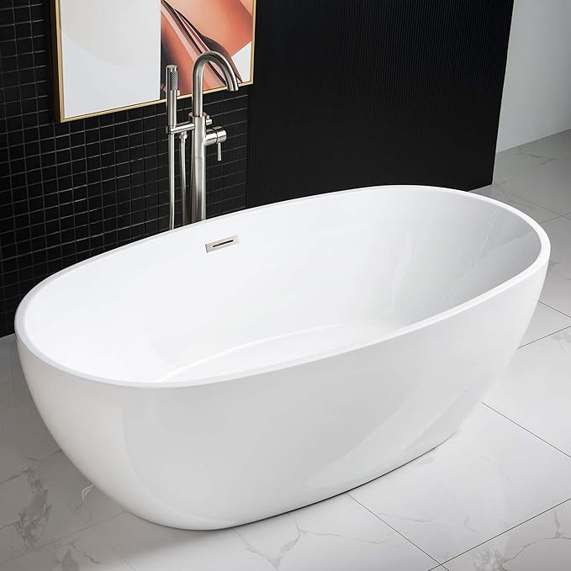

$802

WOODBRIDGE BTA1528-B/N-Drain &O Bathtub, Brushed Nickel