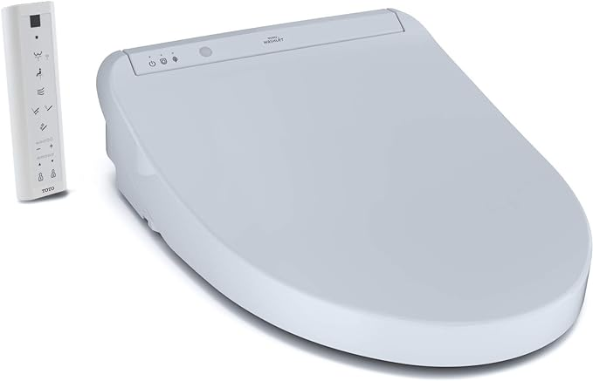

$699

TOTO SW3036R#01 WASHLET K300 Electronic Bidet Toilet Seat, Cotton White