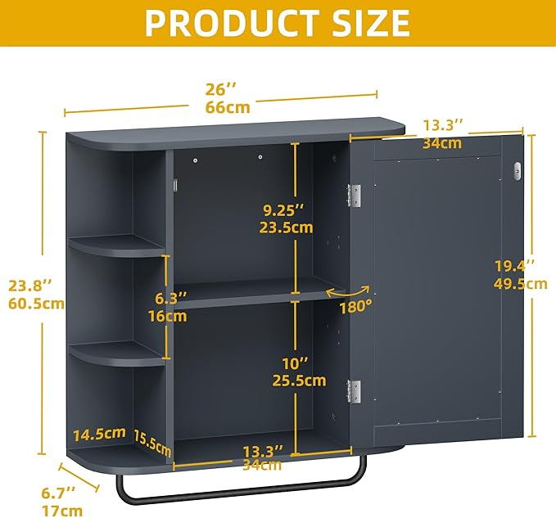

$67

YITAHOME Bathroom Cabinet Medicine Cabinet Organizer, Wall Mounted Bathroom Cabinet with Mirror Door and Removable Shelf for Bathroom Living Room Laundry Bedroom, Purplish Blue