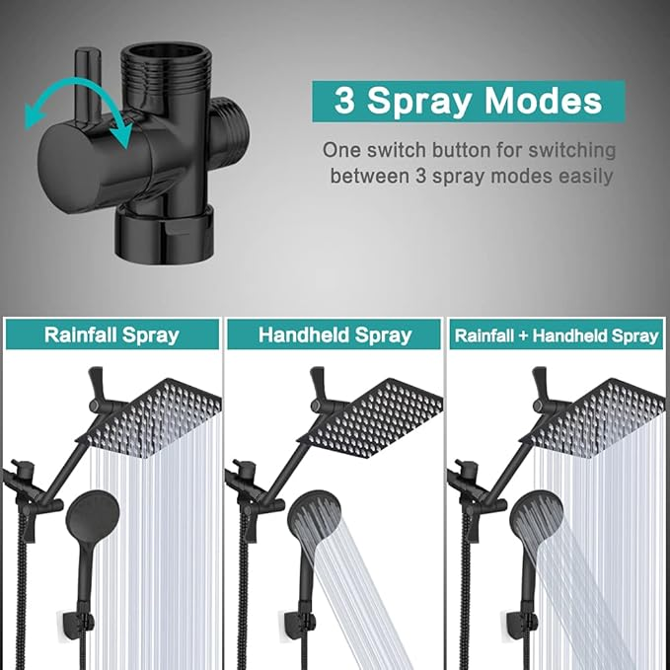

$74

Shower Head, 8‘’ High Pressure Rainfall/Handheld Shower Combo with 11'' Extension Arm, 9 Settings, Anti-leak Shower Head with Holder, Height/Angle Adjustable, Chrome, Matte Black