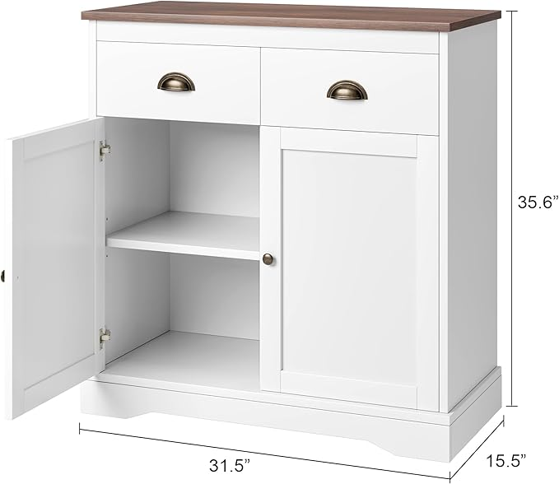

$147

GAOMON Coffee Bar Cabinet, Modern Farmhouse Buffet Cabinet with 2 Drawers and Adjustable Shelf, Double Door Kitchen Cabinet, White