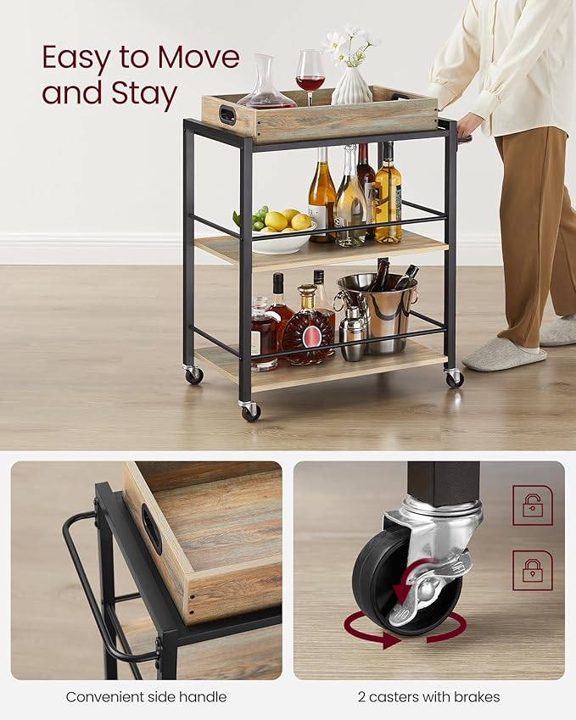

$68

VASAGLE Kitchen Serving Cart with Removable Tray, 3-Tier Kitchen Utility Cart on Wheels with Storage, with Brakes, Leveling Feet, 15.7 x 28.3 x 33.9 Inches, Turquoise Brown and Ink Black ULRC072K60