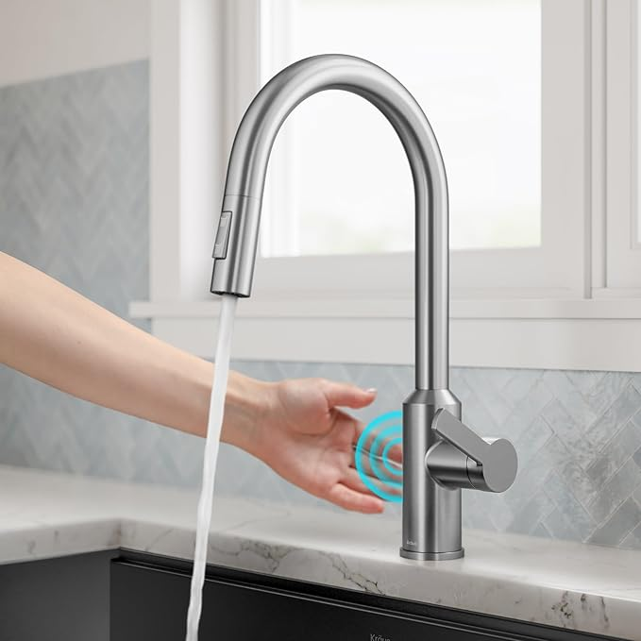

$242

KRAUS Oletto Touchless Sensor Pull-Down Single Handle Kitchen Faucet in Spot-Free Stainless Steel, KSF-2830SFS