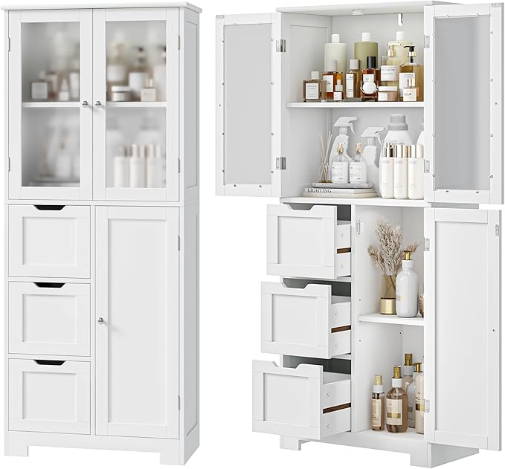

$158

Bathroom Cabinet, Pantry Storage Cabinet with Adjustable Shelf & Drawers, Tall Storage Cabinet with Glass Doors for Kitchen, Dining Room, Bathroom, Living Room, White