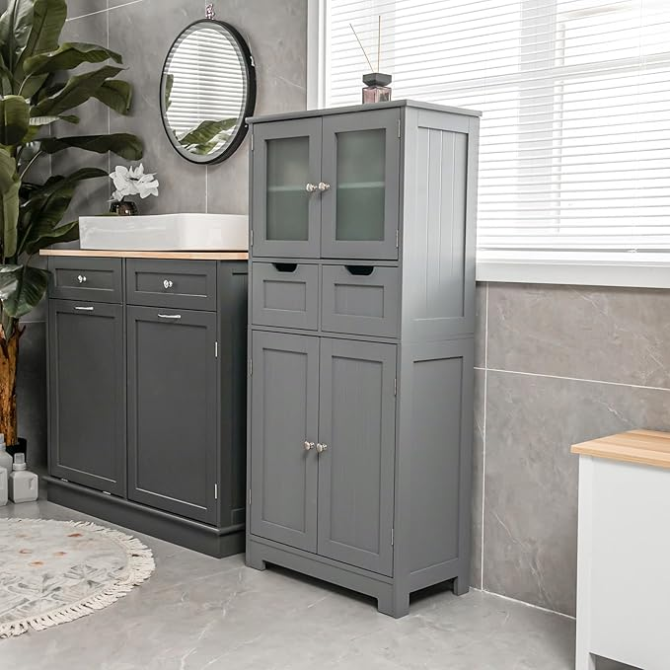

$149

Giantex Bathroom Floor Storage Cabinet - Freestanding Cabinet with 2 Glass Doors, 2 Drawers & Adjustable Shelves, Multifunctional 50.5” Tall Storage Organizer Cupboard for Kitchen, Living Room (Gray)