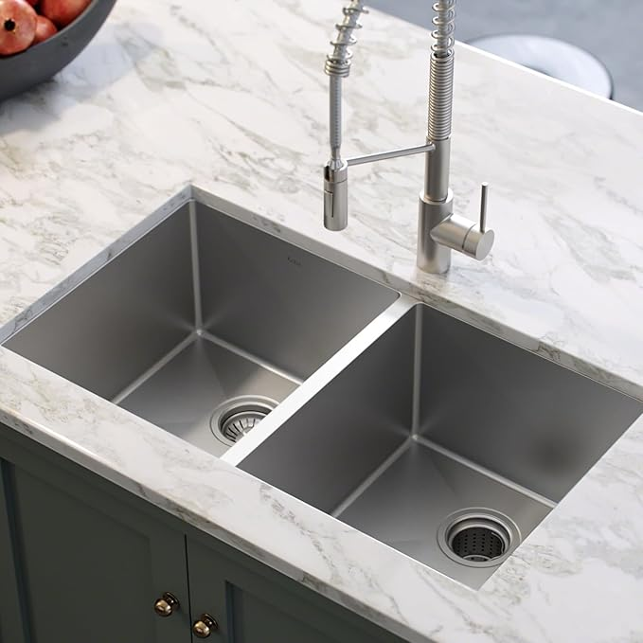

$394

Kraus Standard PRO 33-inch 16 Gauge Undermount 50/50 Double Bowl Stainless Steel Kitchen Sink, KHU102-33

[Visit the Kraus Store](https://www.amazon.com/stores/KRAUS/page/9C38490D-4111-4ED7-BA4E-E298258E4BD2?ref_=ast_bln&store_ref=bl_ast_dp_brandLogo_sto)