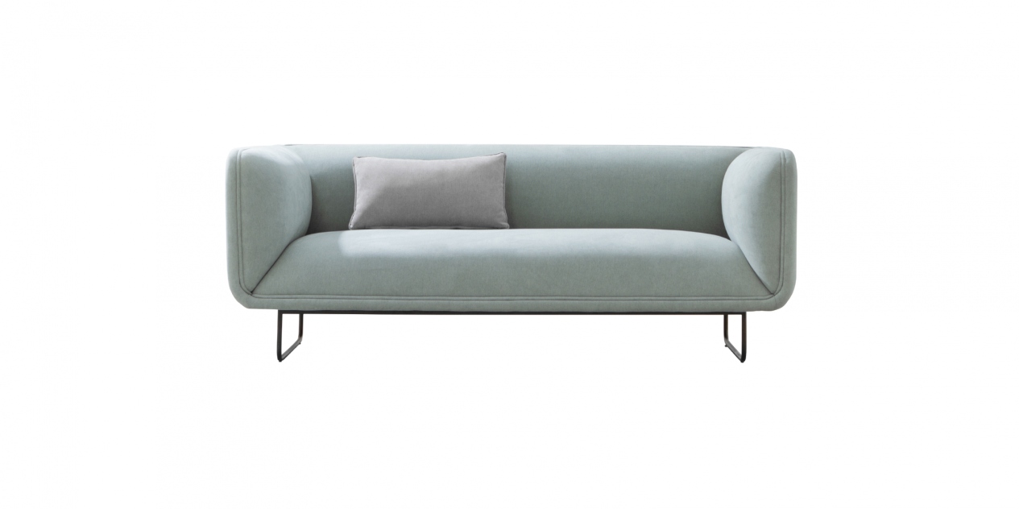

$762,21

Chuub sofa is a simple model in design which will give you a fresh look with its soft, rounded volumes and light colour, yet brings a sense of certainty when sitting.

