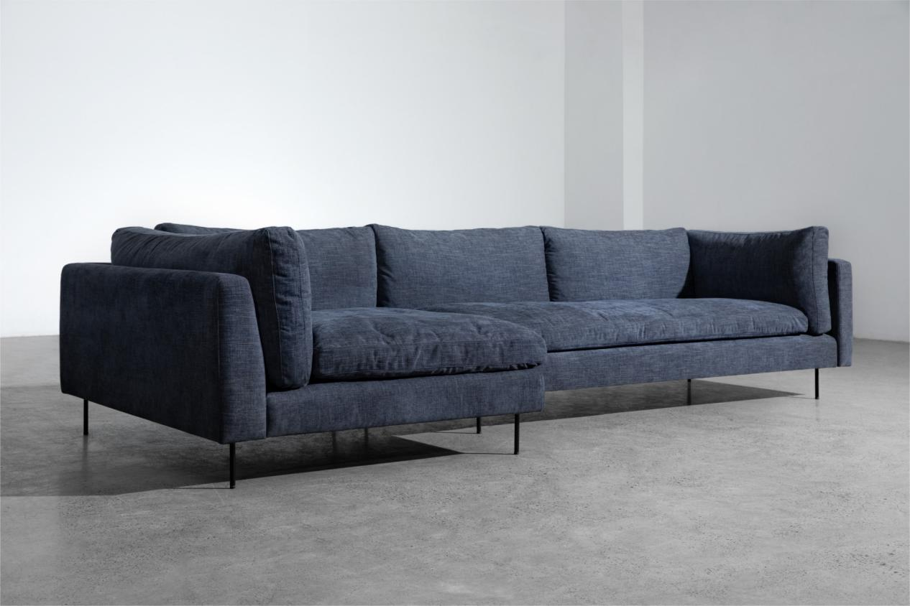

$1.126,90

Let's sink into the extraordinaire comfortable Cloud sofa to enjoy an all-out relaxation. The couch provides a generous depth that builds to laid back, a relaxed yet elegant appearance that undoubtedly brings out the space. Above all, Cloud comes floating into you, not to carry rain or storm, but to invite sitters to dive into its softness.

