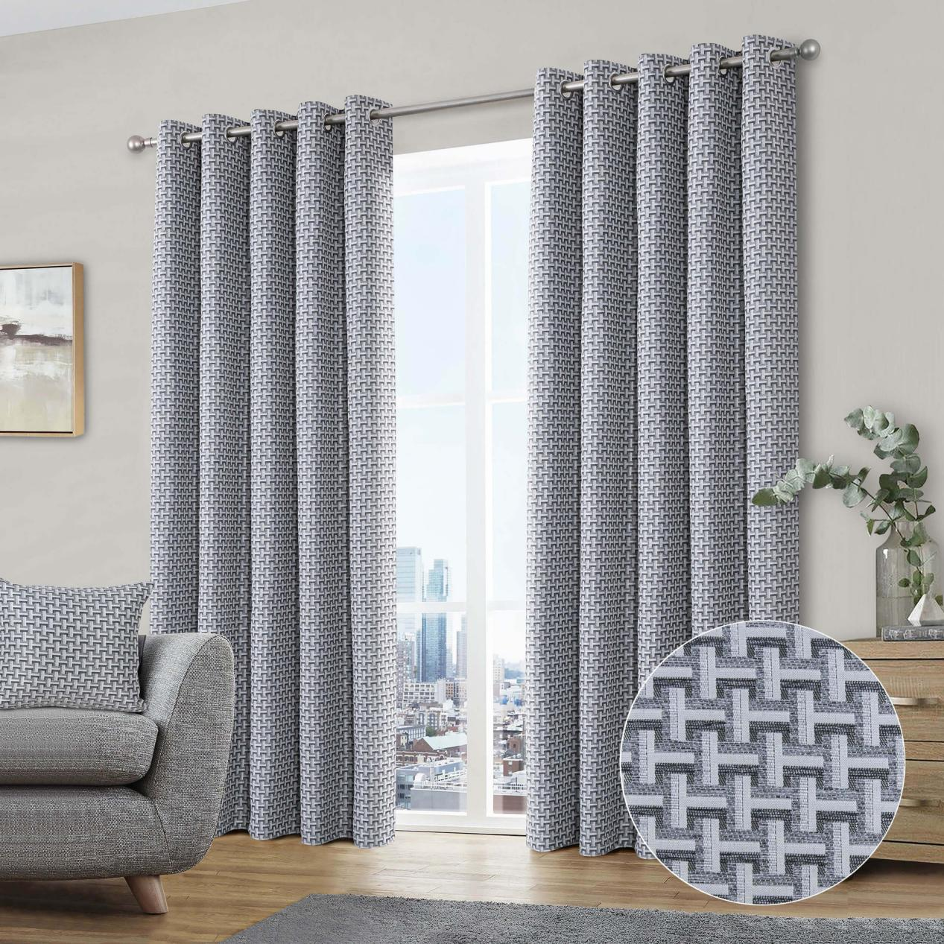

$1120.00

Home Curtains offer hundreds of ready made curtains in a huge variety of different fabrics, designs and colours, and a large range of sizes.  The vast majority of the curtains are lined, thermal, or blackout.  If you don't see the size you need, no problem, just use our alteration service to get the custom drop that you require.