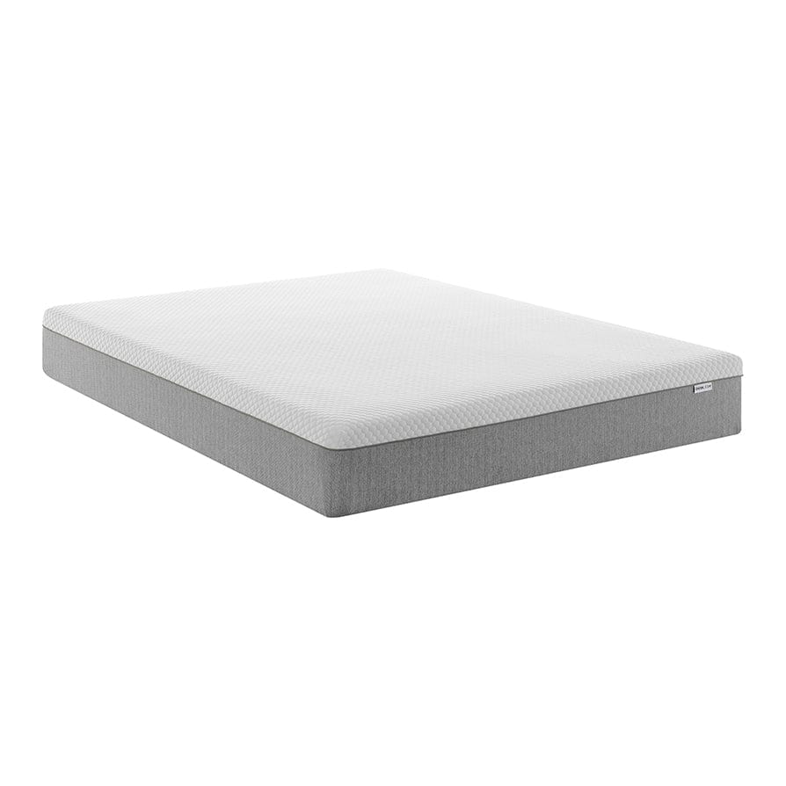

$379.00

Finished with two additional foam layers on either side, they work together for ultimate comfort and pressure relief all night long. Adapting to the way you sleep with balanced support, our 2,000 Pocket Sprung Hybrid Mattress has a luxurious textured outer layer and breathable, allergy-friendly fabric covering the whole of the mattress.