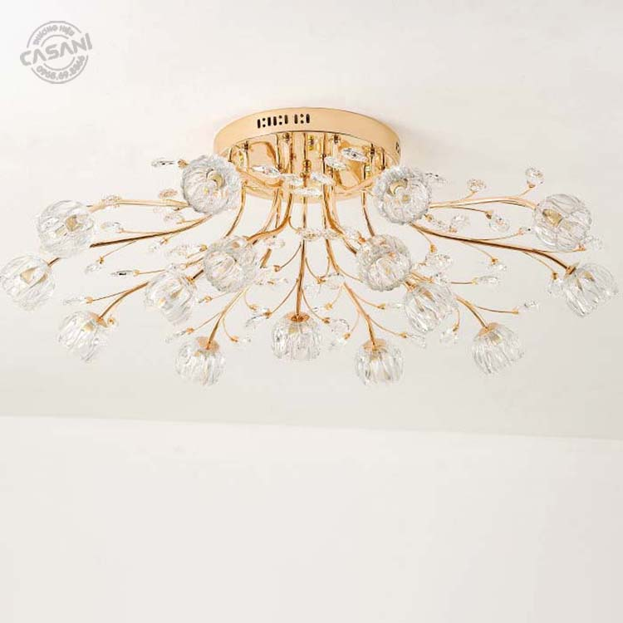

$123.91

Modern Chandelier CCH-3743-15, a symbol of luxury and class. With the shape of rising flower buds, this product is not only a light source but also a great decorative highlight for any space.

Specifications

Size: D800xH300mm

Material: Gold-plated alloy, glass shade

Bulb: G9 bulb

Light: Yellow (can replace 3-color bulb)

Room area: 15-25m2

Ceiling height: Over 2m9

Suitable for: Living room, bedroom, restaurant, hotel....