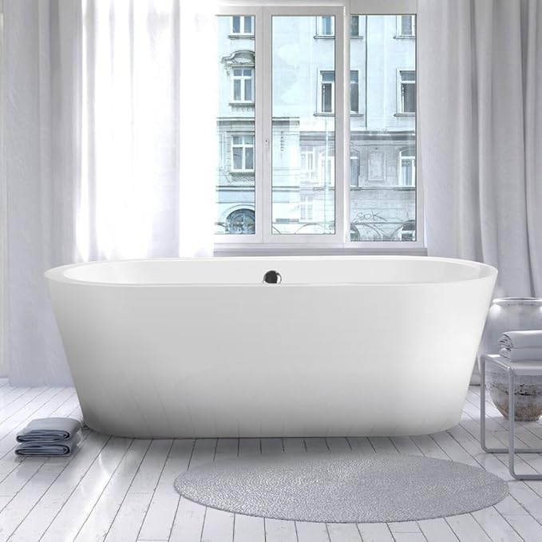

$799

Vinnova 234068-BAT-WH Melania 68 inch x 32 inch Soaking Bathtub,,, White