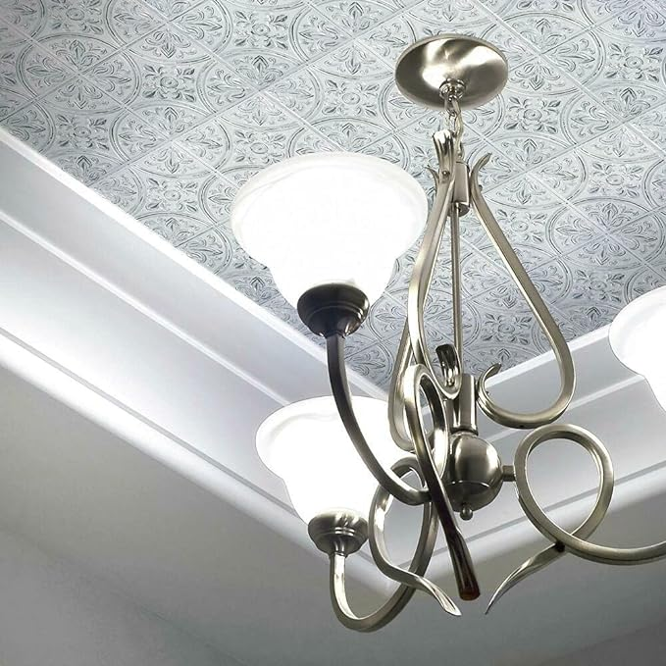

$13

RoomMates TIL4623FLT StickTiles White Tin Peel and Stick Tile Backsplash, 10.5 inch x 10.5 inch, 4 Count (Pack of 1)