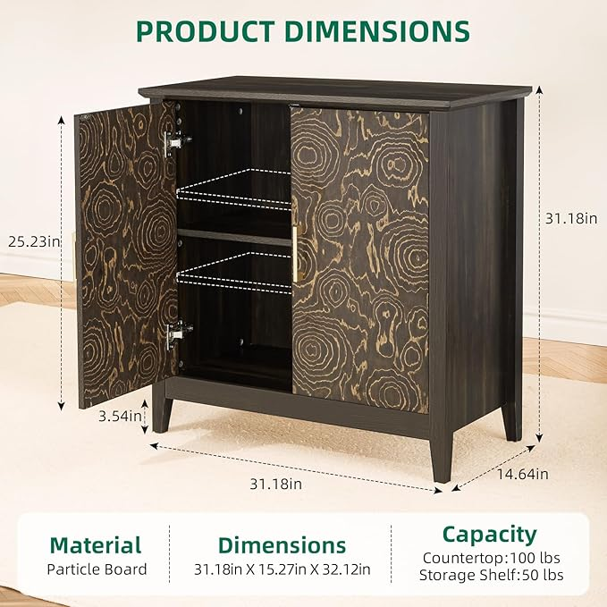

$222

GAOMON Farmhouse Sideboard Buffet Cabinet,Coffee Bar Cabinet with 2 Doors & Adjustable Shelf, Accent Cabinet with Storage, Kitchen Cabinet for Living Room, Entryway