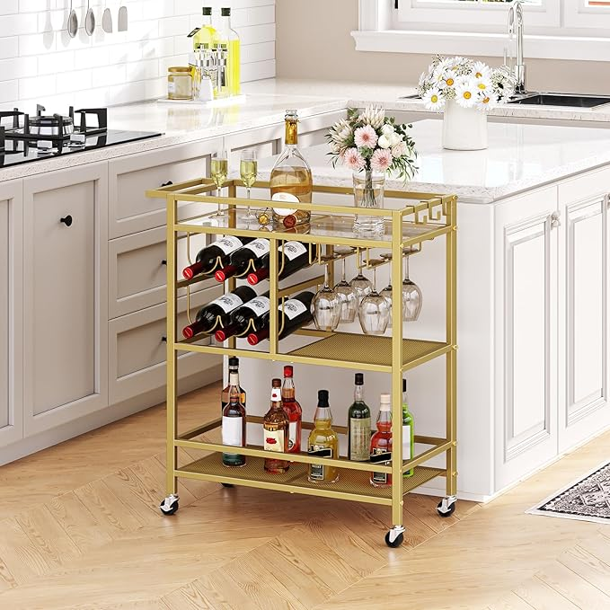

$53

Bar Cart for Home, 3-Tier Serving Cart with Wheels and Handle, Beverage Cart with Wine Rack and Glass Holders, Rolling Wine Cart for Kitchen, Dining Room, Gold RCJ61B01