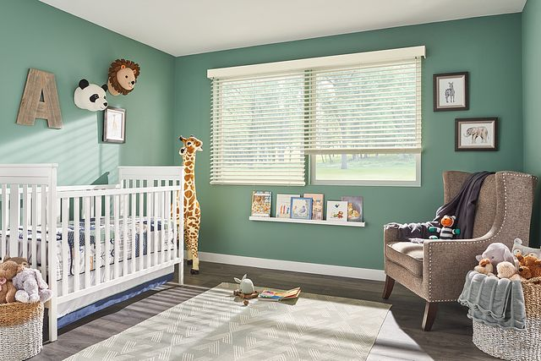

$1456

Feel like you're outside—even when you're not—with the relaxed, natural beauty of Bali Wood Blinds. Durable, warm, and luxurious all at the same time, natural wood blinds instantly turn your windows into the talk of the room.