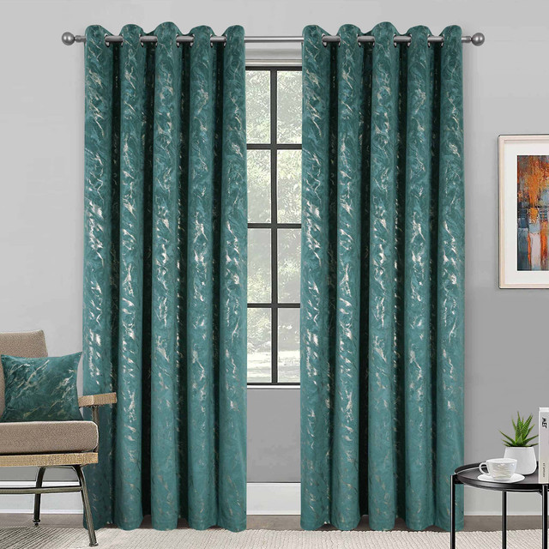

$2013.00

Soft touch matte velour, with marble effect metallic detail, designed with a thick wadded thermal lining to keep the heat in and the cold out. Complete with easy eyelets for effortless hanging.