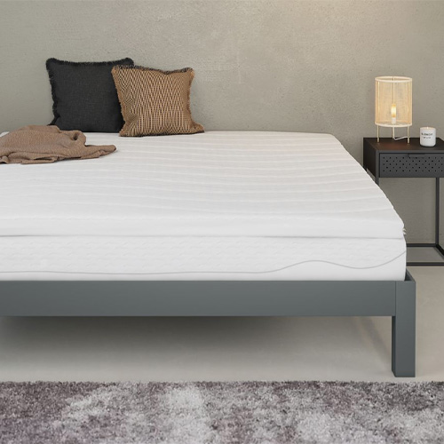

$167.28

Washing: No

Bleaching: No

Tumble dry: No

Ironing: No

Dry clean: No

Stains should be wiped off and dried quickly

Keep the mattress dry daily

The room should be ventilated, reducing humidity

Regularly rotate the mattress head monthly and change the sleeping position weekly to reduce the impact on one area of the mattress