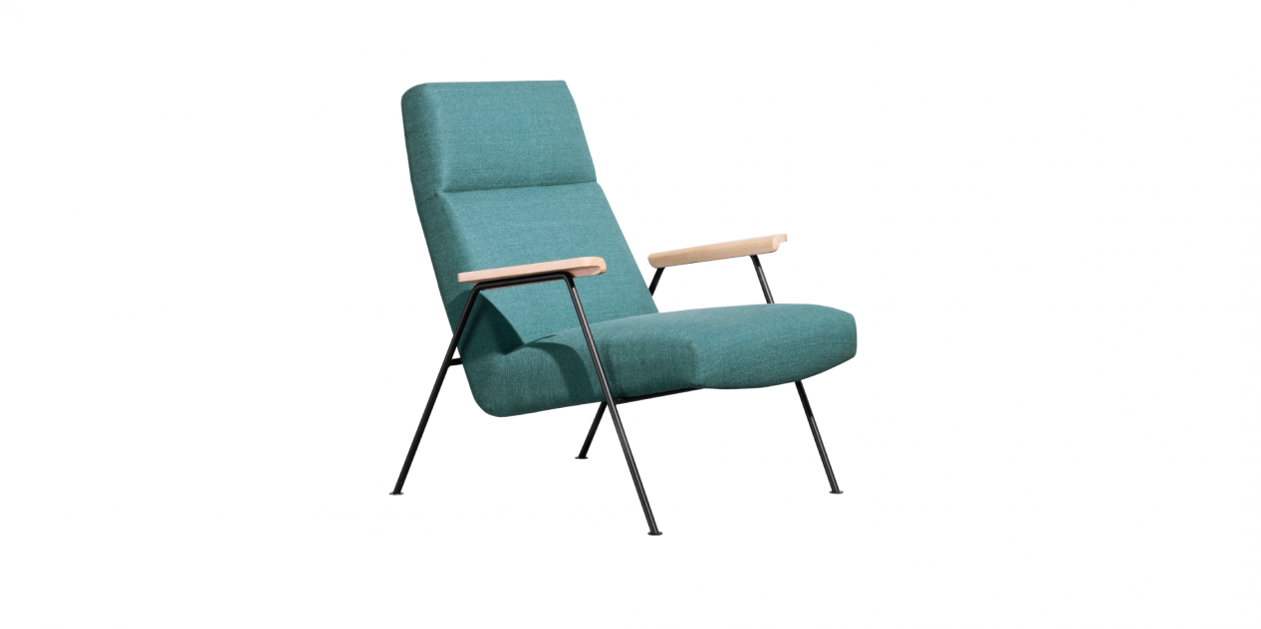

$320,29There's nothing more relaxing than an armchair that makes you feel so relaxed from the moment you sit down and you don’t want to stand up. This Z-A01 armchair has a profile with a headrest that is slightly curved inwards to hug your head and neck; a backrest that reclines gradually, along with wooden armrests, is sure to bring a sense of comfort that you cannot deny.

