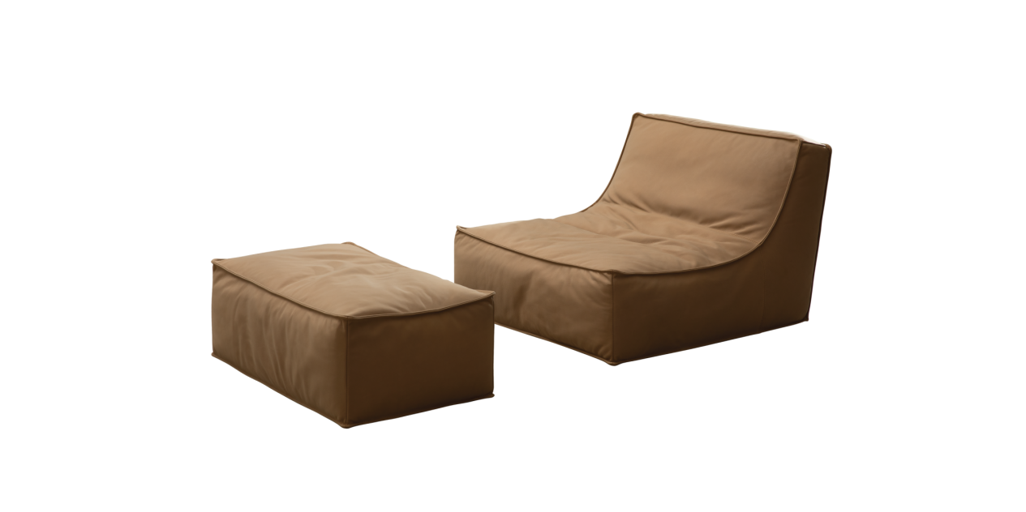

$1.256,84 The simple yet voluminous shape and low profile seating — a subtle combination that makes the Haven armchair a recognizable yet unobtrusive piece of furniture. Characterized by a high backrest with gentle, embracing curves and distinctively soft seat cushion, the Haven armchair invites you to an oasis of calmness and relaxation. The Haven includes an armchair and an ottoman for your ultimate relaxation and comfort. It can be used as a standalone sofa or expanded in size by connecting more modules as needed. Revel in the true comfort with the Haven armchair—your own personal slice of haven.

