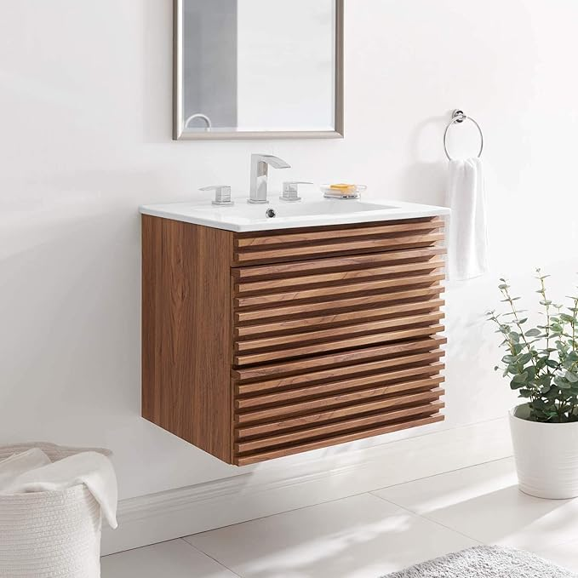

$268

Modway Render 24" Wall-Mount Bathroom Vanity in Walnut White