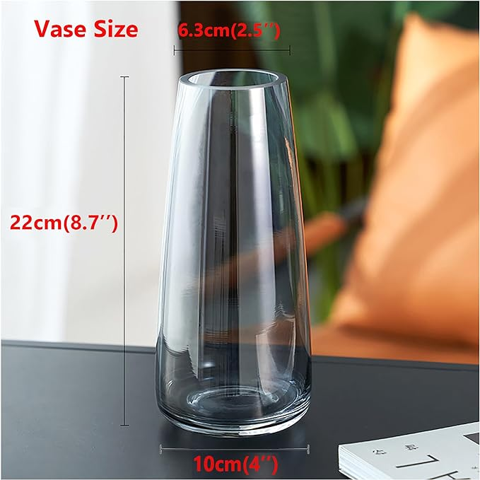

$15

FANTESTICRYAN Modern Glass Vase Irised Crystal Clear Glass Vase for Home Office Decor (Crystal Grey)