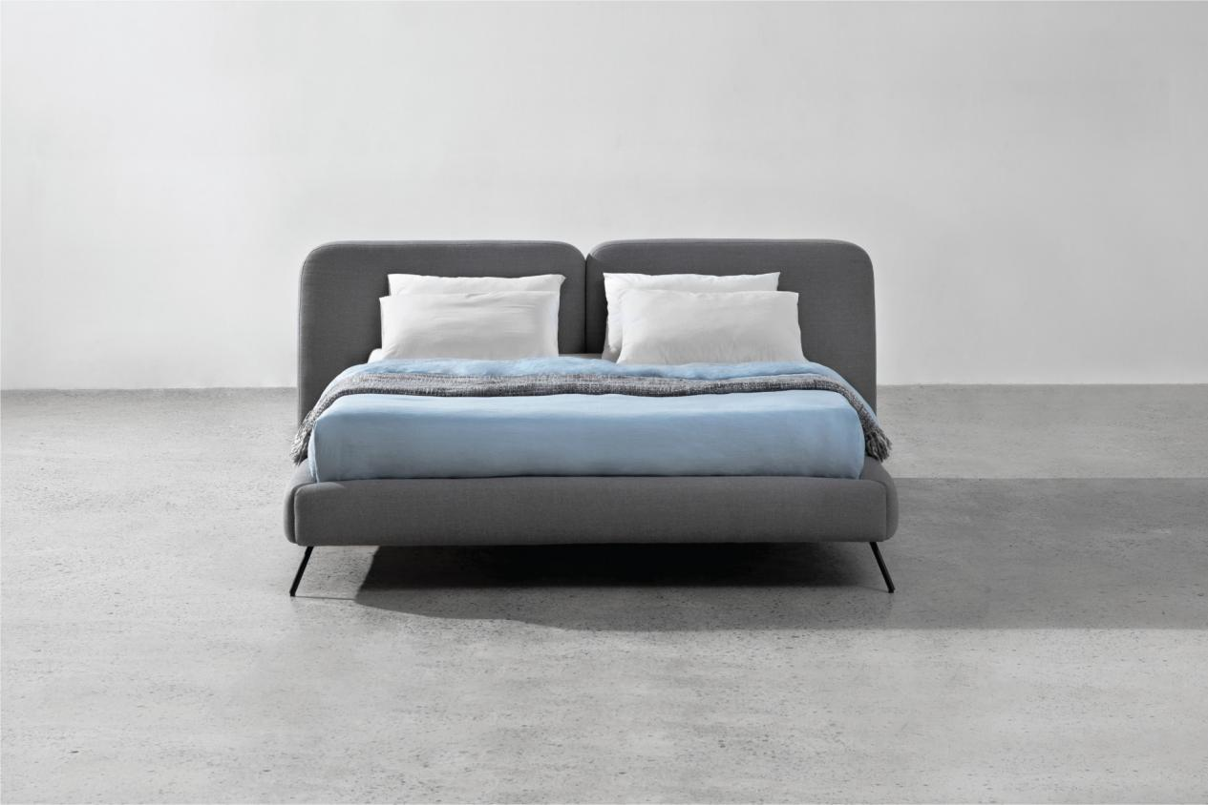

$721,09

A bed should be a perfect piece to end your day with. The Z-B02 bed, coming with all-around curves, a high headboard, and soft upholstery, will enhance the comfiness to completely unwind and ease you gently into a good night's sleep.

