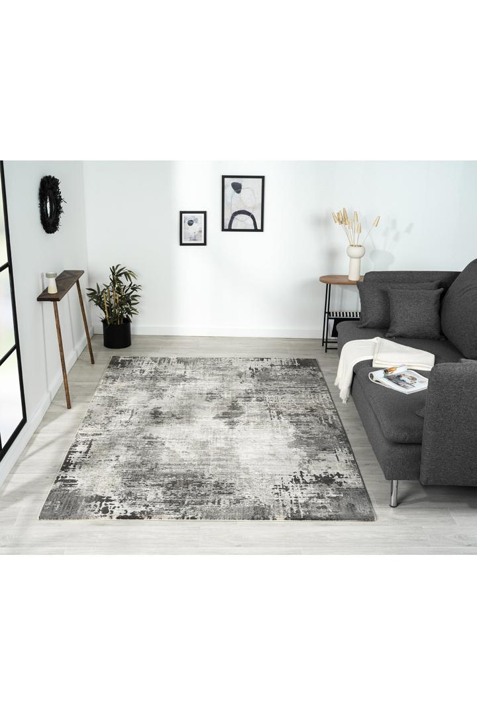

$225

Our "Soft" range is inspired by the endless spheres of the sky and the galaxy, with shades of white and grey building a perfect harmony. The distressed look surely makes this rug a great addition to any space wanting to create a modern, luxurious feel.