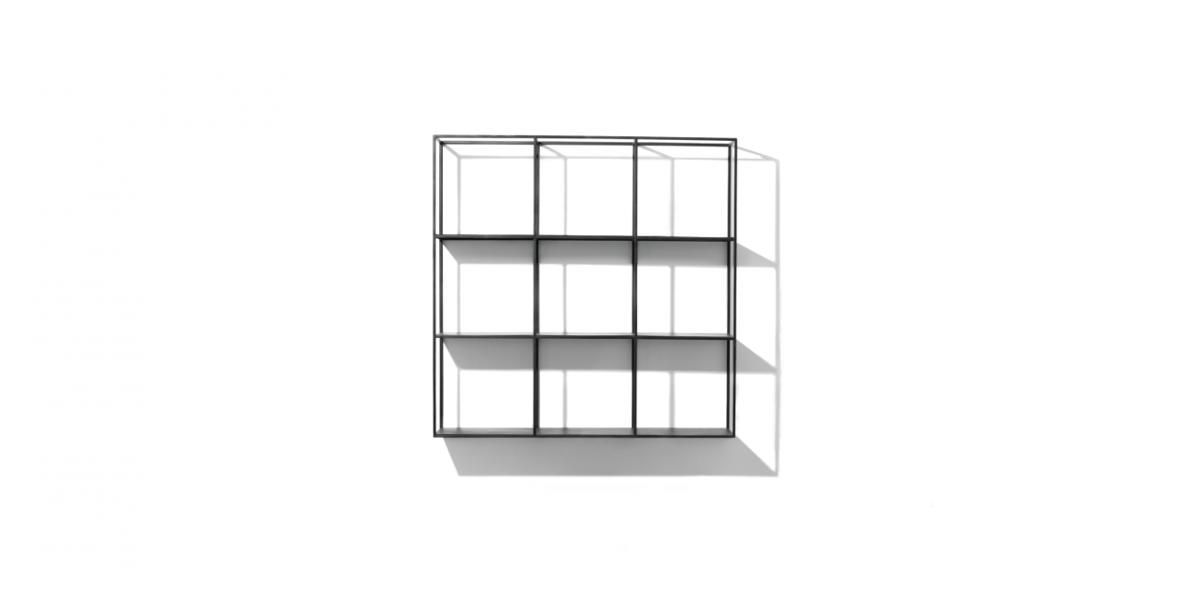

$218,91

Inspired by the rubik's cube, covered with a black powder coating, the Rubik shelf has a very simple and slender design, with small square blocks divided that looks like miniature picture frames, allowing you to feel free to create your personal decorating ideas or simply storing your favorite items."

