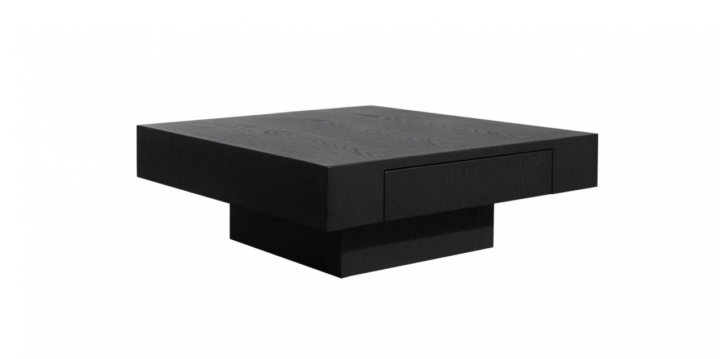

$332,45

Designed with a hidden drawer, the CAP coffee table keeps your essential things looking tidy. Its spacious square tabletop makes it an ideal addition to large sofas and a stand-out feature in any setting.

