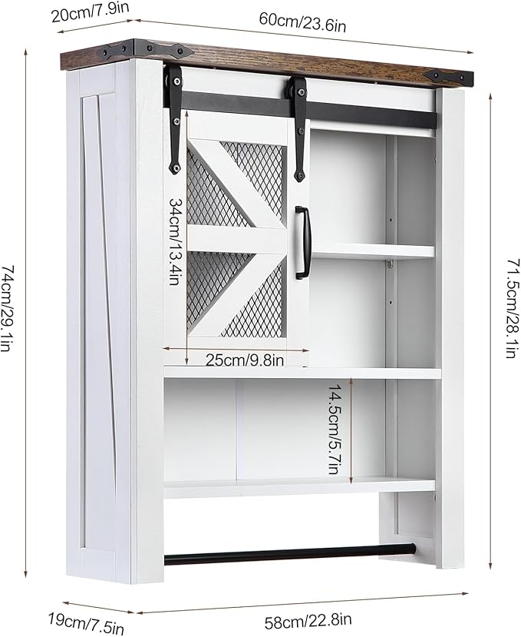

$26

GAOMON Bathroom Organizer Cabinet, Over The Toilet Bathroom Cabinet with Towels Bar & Hooks, 3-Tier Over Toilet Cabinet with Sliding Barn Door for Bathroom Laundry Kitchen, Wall Mounted