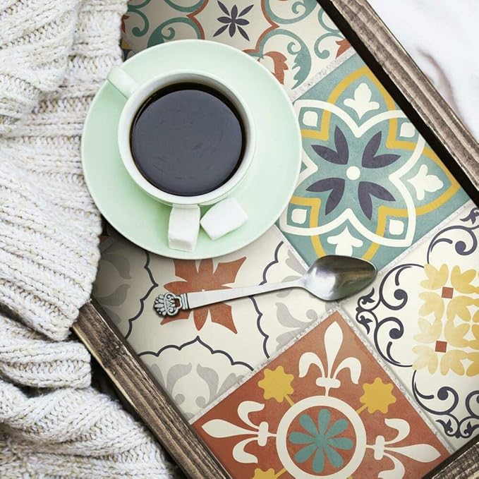

$13

RoomMates TIL4279FLT StickTiles Spanish Terracotta Peel and Stick Tile Backsplash, Yellow,Orange,Blue