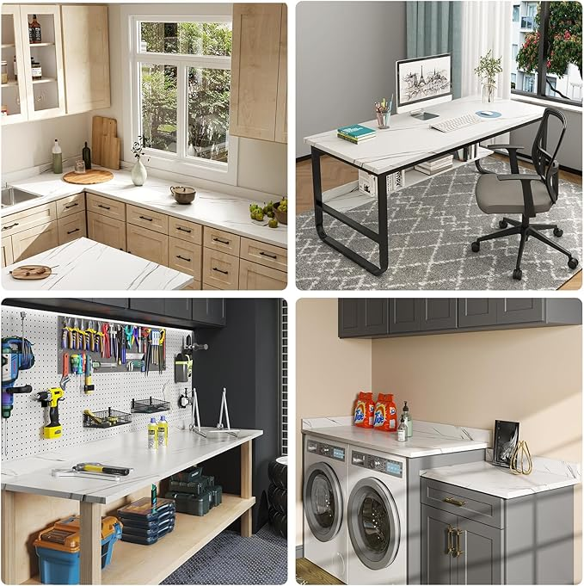

$224

ROOMTEC Laminate Countertop, Wood Countertop for DIY, Table Top, Washer Dryer Counter Top, 48" L x 25.56" W x 0.75" Thick(Marble Texture)