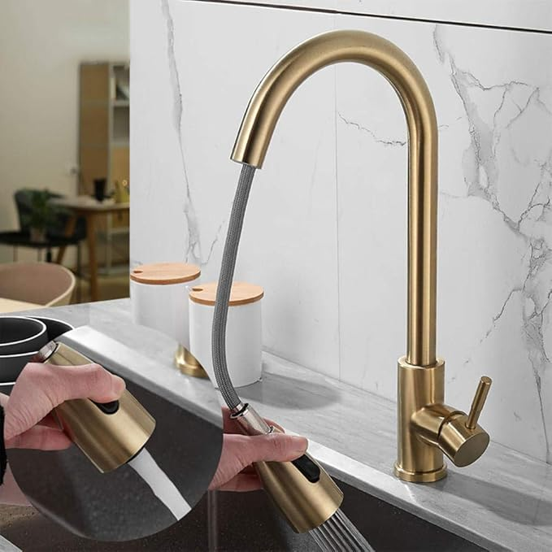

$24

Kitchen faucets with Pull Out Spray Gold Kitchen Sink Faucet Stainless Steel Hot and Cold Retractable Dual Modes Kitchen Mixer Faucet