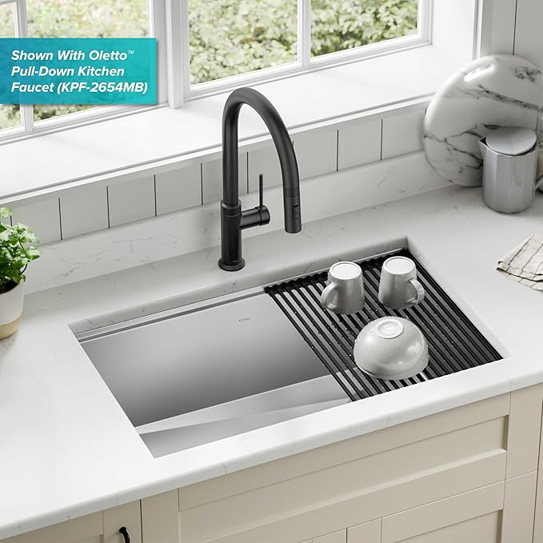

$377

KRAUS Kore 30-Inch Undermount Workstation 16 Gauge Single Bowl Stainless Steel Kitchen Sink with Accessories, KWU110-30

[Visit the Kraus Store](https://www.amazon.com/stores/KRAUS/page/9C38490D-4111-4ED7-BA4E-E298258E4BD2?ref_=ast_bln&store_ref=bl_ast_dp_brandLogo_sto)