PROGRAM:1

XML:

<?xml version="1.0" encoding="utf-8"?>
<LinearLayout xmlns:android="http://schemas.android.com/apk/res/android"
xmlns:app="http://schemas.android.com/apk/res-auto"
xmlns:tools="http://schemas.android.com/tools"
android:layout_width="match_parent"
android:layout_height="match_parent"
android:orientation="vertical"
tools:context=".MainActivity">
<Button
android:layout_width="match_parent"
android:layout_height="wrap_content"
android:text="Click"
android:id="@+id/button"/>
<TextView
android:layout_width="wrap_content"
android:layout_height="wrap_content"
android:text="Hello World!"
android:id="@+id/tv"
/>
</LinearLayout>

JAVA:

package com.example.andlabb.tutorial;
import android.support.v7.app.AppCompatActivity;
import android.os.Bundle;
import android.view.View;
import android.widget.Button;
import android.widget.TextView;
public class MainActivity extends AppCompatActivity {
Button b;
TextView tv;
@Override
protected void onCreate(Bundle savedInstanceState) {
super.onCreate(savedInstanceState);
setContentView(R.layout.activity_main);
b=findViewById(R.id.button);
tv=findViewById(R.id.tv);
b.setOnClickListener(new View.OnClickListener() {
@Override
public void onClick(View v) {
tv.setText("you have clicked the button");
}
});
}
}

OUTPUT:

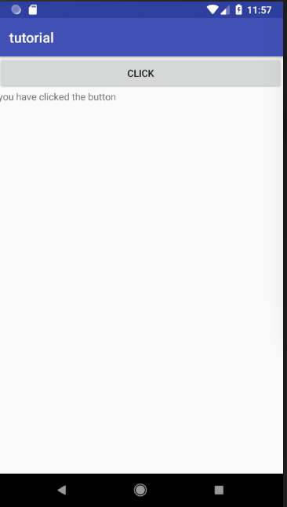

PROGRAM:2

XML:

<?xml version="1.0" encoding="utf-8"?>
<LinearLayout xmlns:android="http://schemas.android.com/apk/res/android"
xmlns:app="http://schemas.android.com/apk/res-auto"
xmlns:tools="http://schemas.android.com/tools"
android:layout_width="match_parent"
android:layout_height="match_parent"
android:orientation="vertical"
tools:context=".Main2Activity">
<CheckBox
android:id="@+id/india"
android:layout_width="match_parent"
android:layout_height="wrap_content"
android:text="INDIA"/>
<CheckBox
android:id="@+id/sri"
android:layout_width="match_parent"
android:layout_height="wrap_content"
android:text="SRILANKA"/>
<CheckBox
android:id="@+id/paki"
android:layout_width="match_parent"
android:layout_height="wrap_content"
android:text="PAKISTHAN"/>
<TextView
android:layout_width="wrap_content"
android:layout_height="wrap_content"
android:text="Hello World!"
android:id="@+id/tv"
/>
</LinearLayout>

JAVA:

package com.example.andlabb.tutorial;
import android.support.v7.app.AppCompatActivity;
import android.os.Bundle;
import android.widget.CheckBox;
import android.widget.CompoundButton;
import android.widget.TextView;
public class Main2Activity extends AppCompatActivity {
TextView tv;
CheckBox cb1,cb2,cb3;
@Override
protected void onCreate(Bundle savedInstanceState) {
super.onCreate(savedInstanceState);
setContentView(R.layout.activity_main2);
tv=findViewById(R.id.tv);
cb1=findViewById(R.id.india);
cb2=findViewById(R.id.sri);
cb3=findViewById(R.id.paki);
cb1.setOnCheckedChangeListener(new CompoundButton.OnCheckedChangeListener() {
@Override
public void onCheckedChanged(CompoundButton buttonView, boolean isChecked) {
if(isChecked)
{
tv.setText("INDIA");
}
}
});
cb2.setOnCheckedChangeListener(new CompoundButton.OnCheckedChangeListener() {
@Override
public void onCheckedChanged(CompoundButton buttonView, boolean isChecked) {
if(isChecked)
{
tv.setText("SRILANKA");
}
}
});
cb3.setOnCheckedChangeListener(new CompoundButton.OnCheckedChangeListener() {
@Override
public void onCheckedChanged(CompoundButton buttonView, boolean isChecked) {
if(isChecked)
{
tv.setText("PAKISTHAN");
}
}
});
}
}
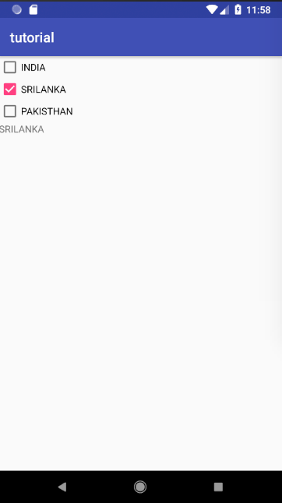
OUTPUT:

PROGRAM:3

XML:

<?xml version="1.0" encoding="utf-8"?>
<LinearLayout xmlns:android="http://schemas.android.com/apk/res/android"
xmlns:app="http://schemas.android.com/apk/res-auto"
xmlns:tools="http://schemas.android.com/tools"
android:layout_width="match_parent"
android:layout_height="match_parent"
android:orientation="vertical"
tools:context=".Main2Activity">
<CheckBox
android:id="@+id/india"
android:layout_width="match_parent"
android:layout_height="wrap_content"
android:text="INDIA"/>
<CheckBox
android:id="@+id/sri"
android:layout_width="match_parent"
android:layout_height="wrap_content"
android:text="SRILANKA"/>
<CheckBox
android:id="@+id/paki"
android:layout_width="match_parent"
android:layout_height="wrap_content"
android:text="PAKISTHAN"/>
<EditText
android:layout_width="wrap_content"
android:layout_height="wrap_content"
android:text="Hello World!"
android:id="@+id/tv"
/>
</LinearLayout>

JAVA:

package com.example.andlabb.tutorial;
import android.support.v7.app.AppCompatActivity;
import android.os.Bundle;
import android.widget.CheckBox;
import android.widget.CompoundButton;
import android.widget.EditText;
import android.widget.TextView;
import java.util.ArrayList;
public class Main3Activity extends AppCompatActivity {
EditText et;
CheckBox cb1,cb2,cb3;
ArrayList<String> s = new ArrayList<String>();
@Override
protected void onCreate(Bundle savedInstanceState) {
super.onCreate(savedInstanceState);
setContentView(R.layout.activity_main3);
et=findViewById(R.id.tv);
cb1=findViewById(R.id.india);
cb2=findViewById(R.id.sri);
cb3=findViewById(R.id.paki);
cb1.setOnCheckedChangeListener(new CompoundButton.OnCheckedChangeListener() {
@Override
public void onCheckedChanged(CompoundButton buttonView, boolean isChecked) {
if(isChecked)
{
s.add("INDIA");
et.setText(s.toString());
}
else {
s.remove("INDIA");
et.setText(s.toString());
}
}
});
cb2.setOnCheckedChangeListener(new CompoundButton.OnCheckedChangeListener() {
@Override
public void onCheckedChanged(CompoundButton buttonView, boolean isChecked) {
if(isChecked)
{
s.add("SRILANKA");
et.setText(s.toString());
}
else {
s.remove("SRILANKA");
et.setText(s.toString());
}
}
});
cb3.setOnCheckedChangeListener(new CompoundButton.OnCheckedChangeListener() {
@Override
public void onCheckedChanged(CompoundButton buttonView, boolean isChecked) {
if(isChecked)
{
s.add("PAKISTAN");
et.setText(s.toString());
}
else {
s.remove("PAKISTAN");
et.setText(s.toString());
}
}
});
}
}
OUTPUT:

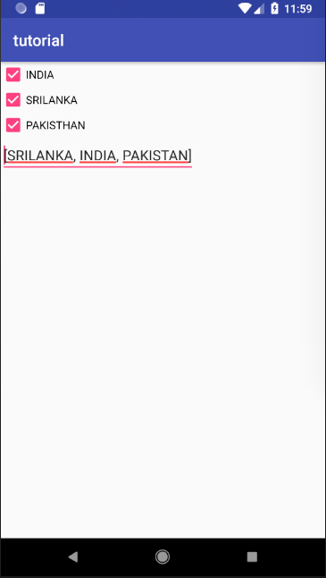

PROGRAM:4

XML:

<?xml version="1.0" encoding="utf-8"?>
<LinearLayout xmlns:android="http://schemas.android.com/apk/res/android"
xmlns:app="http://schemas.android.com/apk/res-auto"
xmlns:tools="http://schemas.android.com/tools"
android:layout_width="match_parent"
android:layout_height="match_parent"
android:orientation="vertical"
tools:context=".Main4Activity">
<ToggleButton
android:layout_width="match_parent"
android:layout_height="wrap_content"
android:id="@+id/tb"/>
<ToggleButton
android:layout_width="match_parent"
android:layout_height="wrap_content"
android:id="@+id/tb1"/>
<Button
android:layout_width="match_parent"
android:layout_height="wrap_content"
android:text="click"/>
</LinearLayout>

JAVA:

package com.example.andlabb.tutorial;
import android.support.v7.app.AppCompatActivity;
import android.os.Bundle;
import android.widget.CompoundButton;
import android.widget.Toast;
import android.widget.ToggleButton;
public class Main4Activity extends AppCompatActivity {
ToggleButton tb;
@Override
protected void onCreate(Bundle savedInstanceState) {
super.onCreate(savedInstanceState);
setContentView(R.layout.activity_main4);
tb=findViewById(R.id.tb);
tb.setOnCheckedChangeListener(new CompoundButton.OnCheckedChangeListener() {
@Override
public void onCheckedChanged(CompoundButton buttonView, boolean isChecked) {
if(isChecked)
Toast.makeText(getApplicationContext(),"on",Toast.LENGTH_LONG).show();
else
Toast.makeText(getApplicationContext(),"off",Toast.LENGTH_LONG).show();
}
});
}
}
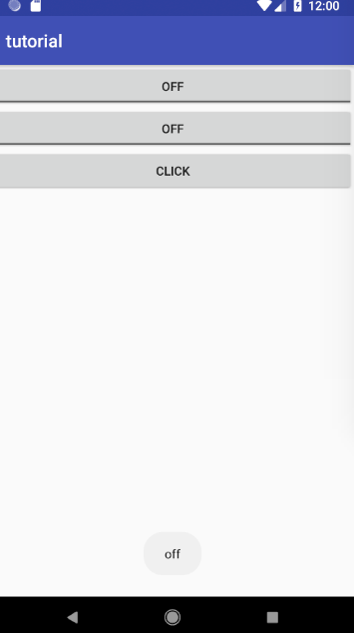

PROGRAM:5

XML:

<?xml version="1.0" encoding="utf-8"?>
<LinearLayout xmlns:android="http://schemas.android.com/apk/res/android"
xmlns:app="http://schemas.android.com/apk/res-auto"
xmlns:tools="http://schemas.android.com/tools"
android:layout_width="match_parent"
android:layout_height="match_parent"
android:orientation="vertical"
tools:context=".Main5Activity">
<RadioGroup
android:id="@+id/gender"
android:layout_width="match_parent"
android:layout_height="wrap_content">
<RadioButton
android:id="@+id/male"
android:layout_width="match_parent"
android:layout_height="match_parent"
android:text="Male"/>
<RadioButton
android:id="@+id/female"
android:layout_width="match_parent"
android:layout_height="match_parent"
android:text="Female"/>
</RadioGroup>
<TextView
android:layout_width="match_parent"
android:layout_height="wrap_content"
android:id="@+id/tv"/>
</LinearLayout>

JAVA:

package com.example.andlabb.tutorial;
import android.support.v7.app.AppCompatActivity;
import android.os.Bundle;
import android.widget.CompoundButton;
import android.widget.RadioButton;
import android.widget.RadioGroup;
import android.widget.TextView;
import android.widget.Toast;
public class Main5Activity extends AppCompatActivity {
RadioGroup rg;
RadioButton rb;
TextView tv;
@Override
protected void onCreate(Bundle savedInstanceState) {
super.onCreate(savedInstanceState);
setContentView(R.layout.activity_main5);
rg=findViewById(R.id.gender);
tv=findViewById(R.id.tv);
rg.setOnCheckedChangeListener(new RadioGroup.OnCheckedChangeListener() {
@Override
public void onCheckedChanged(RadioGroup group, int checkedId) {
int selectedId = rg.getCheckedRadioButtonId();
// find the radiobutton by returned id
rb = (RadioButton) findViewById(selectedId);
tv.setText(rb.getText());
}
});
}
}
OUTPUT:

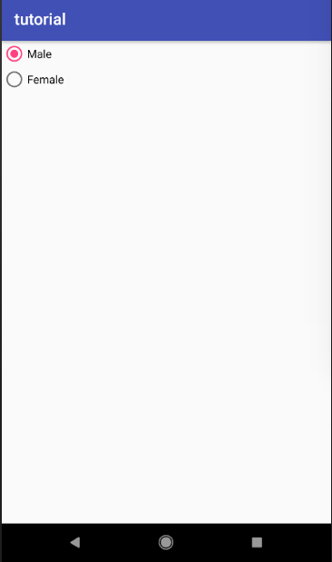

PROGRAM:6

XML:

<?xml version="1.0" encoding="utf-8"?>
<LinearLayout xmlns:android="http://schemas.android.com/apk/res/android"
xmlns:app="http://schemas.android.com/apk/res-auto"
xmlns:tools="http://schemas.android.com/tools"
android:layout_width="match_parent"
android:layout_height="match_parent"
tools:context=".Main6Activity">
<AutoCompleteTextView
android:id="@+id/autoCompleteTextView"
android:layout_width="200dp"
android:layout_height="wrap_content"
android:layout_marginLeft="92dp"
android:layout_marginTop="144dp"
android:text=""
app:layout_constraintStart_toStartOf="parent"
app:layout_constraintTop_toTopOf="parent" />
</LinearLayout>

JAVA:

package com.example.andlabb.tutorial;
import android.support.v7.app.AppCompatActivity;
import android.os.Bundle;
import android.widget.ArrayAdapter;
import android.widget.AutoCompleteTextView;
public class Main6Activity extends AppCompatActivity {
String[] language ={"C","C++","Java",".NET","iPhone","Android","ASP.NET","PHP"};
@Override
protected void onCreate(Bundle savedInstanceState) {
super.onCreate(savedInstanceState);
setContentView(R.layout.activity_main6);
ArrayAdapter<String> adapter = new ArrayAdapter<String>
(this,android.R.layout.select_dialog_item,language);
//Getting the instance of AutoCompleteTextView
AutoCompleteTextView actv = (AutoCompleteTextView)findViewById(R.id.autoCompleteTextView);
actv.setThreshold(1);//will start working from first character
actv.setAdapter(adapter);//setting the adapter data into the AutoCompleteTextView
}}

OUTPUT:

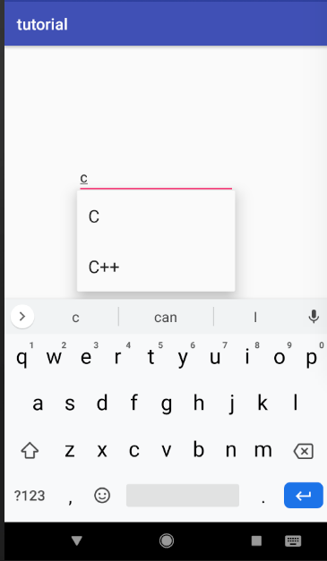

PROGRAM:7

XML:

<?xml version="1.0" encoding="utf-8"?>
<LinearLayout xmlns:android="http://schemas.android.com/apk/res/android"
xmlns:app="http://schemas.android.com/apk/res-auto"
xmlns:tools="http://schemas.android.com/tools"
android:layout_width="match_parent"
android:layout_height="match_parent"
android:orientation="vertical"
tools:context=".Main7Activity">
<ImageView
android:layout_width="match_parent"
android:layout_height="0dp"
android:src="@drawable/android1"
android:layout_weight="10"
android:id="@+id/image"/>
<Button
android:id="@+id/b"
android:layout_width="match_parent"
android:layout_height="0dp"
android:text="Change Image"
android:layout_weight="1"/>
</LinearLayout>

JAVA:

package com.example.andlabb.tutorial;
import android.support.v7.app.AppCompatActivity;
import android.os.Bundle;
import android.view.View;
import android.widget.Button;
import android.widget.ImageView;
public class Main7Activity extends AppCompatActivity {
ImageView iv;
Button b;
int i=0;
@Override
protected void onCreate(Bundle savedInstanceState) {
super.onCreate(savedInstanceState);
setContentView(R.layout.activity_main7);
iv=findViewById(R.id.image);
b=findViewById(R.id.b);
b.setOnClickListener(new View.OnClickListener() {
@Override
public void onClick(View v) {
if(i==0)
{
iv.setImageResource(R.drawable.android1);
i=1;
}else if(i==1)
{
iv.setImageResource(R.drawable.android2);
i=0;
}
}
});
}
} OUTPUT:

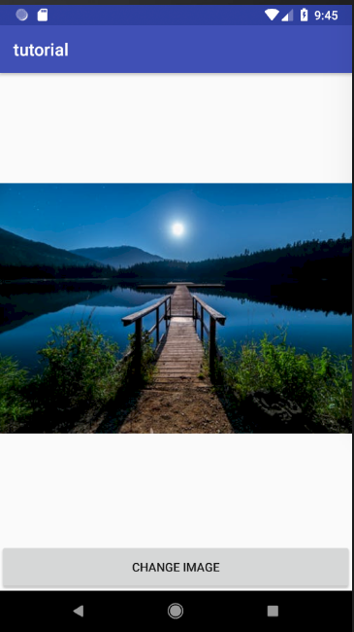

PROGRAM:8

XML:

<?xml version="1.0" encoding="utf-8"?>
<RelativeLayout xmlns:android="http://schemas.android.com/apk/res/android"
xmlns:tools="http://schemas.android.com/tools"
android:layout_width="match_parent"
android:layout_height="match_parent"
android:id="@+id/abc"
tools:context=".MainActivity">

<ImageButton
android:id="@+id/simpleImageButtonHome"
android:layout_width="100dp"
android:layout_height="100dp"
android:layout_centerHorizontal="true"
android:background="@drawable/utube"
android:padding="20dp"
android:scaleType="fitCenter"
android:src="@drawable/home" />
<ImageButton
android:id="@+id/simpleImageButtonYouTube"
android:layout_width="100dp"
android:layout_height="100dp"
android:layout_below="@+id/simpleImageButtonHome"
android:layout_centerHorizontal="true"
android:layout_marginTop="20dp"
android:background="#005"
android:padding="20dp"
android:scaleType="fitCenter"
android:src="@drawable/utube" />
</RelativeLayout>

JAVA:

package com.example.andlabb.tutorial;
import android.app.Activity;
import android.graphics.Color;
import android.support.v7.app.AppCompatActivity;
import android.os.Bundle;
import android.view.Menu;
import android.view.MenuItem;
import android.view.View;
import android.widget.ImageButton;
import android.widget.RelativeLayout;
import android.widget.Toast;
public class Main8Activity extends Activity {
RelativeLayout tl;
@Override
protected void onCreate(Bundle savedInstanceState) {
super.onCreate(savedInstanceState);
setContentView(R.layout.activity_main8);
tl=findViewById(R.id.abc);
// initiate view's
ImageButton simpleImageButtonHome = (ImageButton)findViewById(R.id.simpleImageButtonHome);
ImageButton simpleImageButtonYouTube = (ImageButton)findViewById(R.id.simpleImageButtonYouTube);
// perform click event on button's
simpleImageButtonHome.setOnClickListener(new View.OnClickListener() {
@Override
public void onClick(View view) {
tl.setBackgroundResource(R.drawable.home);
}
});
simpleImageButtonYouTube.setOnClickListener(new View.OnClickListener() {
@Override
public void onClick(View view) {
tl.setBackgroundResource(R.drawable.utube);
}
});
}

OUTPUT:



PROGRAM:9

XML:
<?xml version="1.0" encoding="utf-8"?>
<LinearLayout xmlns:android="http://schemas.android.com/apk/res/android"
xmlns:app="http://schemas.android.com/apk/res-auto"
xmlns:tools="http://schemas.android.com/tools"
android:layout_width="match_parent"
android:layout_height="match_parent"
android:orientation="vertical"
tools:context=".Main9Activity">
<TimePicker
android:layout_width="match_parent"
android:layout_height="wrap_content"
android:id="@+id/timepicker"
></TimePicker>
<Button
android:layout_width="match_parent"
android:layout_height="wrap_content"
android:text="pick"
android:id="@+id/b"/>
<TextView
android:layout_width="match_parent"
android:layout_height="wrap_content"
android:textAlignment="center"
android:textSize="35dp"
android:id="@+id/tv"/>
</LinearLayout>

JAVA:

package com.example.andlabb.tutorial;
import android.os.Build;
import android.support.annotation.RequiresApi;
import android.support.v7.app.AppCompatActivity;
import android.os.Bundle;
import android.view.View;
import android.widget.Button;
import android.widget.TextView;
import android.widget.TimePicker;
public class Main9Activity extends AppCompatActivity {
TimePicker tp;
Button b;
TextView tv;
@Override
protected void onCreate(Bundle savedInstanceState) {
super.onCreate(savedInstanceState);
setContentView(R.layout.activity_main9);
tp=findViewById(R.id.timepicker);
b=findViewById(R.id.b);
tv=findViewById(R.id.tv);
b.setOnClickListener(new View.OnClickListener() {
@RequiresApi(api = Build.VERSION_CODES.M)
@Override
public void onClick(View v) {
tv.setText(tp.getHour()+":"+tp.getMinute());
}
});
}
}

OUTPUT:
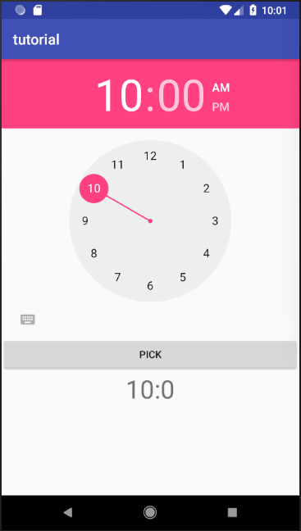

PROGRAM:10

XML:

<?xml version="1.0" encoding="utf-8"?>
<LinearLayout xmlns:android="http://schemas.android.com/apk/res/android"
xmlns:app="http://schemas.android.com/apk/res-auto"
xmlns:tools="http://schemas.android.com/tools"
android:layout_width="match_parent"
android:layout_height="match_parent"
android:orientation="vertical"
tools:context=".Main9Activity">
<DatePicker
android:id="@+id/date_picker"
android:layout_width="match_parent"
android:calendarViewShown="true"
android:spinnersShown="false"
android:layout_weight="4"
android:layout_height="0dp" />
<Button
android:layout_width="match_parent"
android:layout_height="wrap_content"
android:text="pick"
android:id="@+id/b"/>
<TextView
android:layout_width="match_parent"
android:layout_height="wrap_content"
android:textAlignment="center"
android:textSize="35dp"
android:id="@+id/tv"/>
</LinearLayout>

JAVA:

package com.example.andlabb.tutorial;
import android.os.Build;
import android.support.annotation.RequiresApi;
import android.support.v7.app.AppCompatActivity;
import android.os.Bundle;
import android.view.View;
import android.widget.Button;
import android.widget.DatePicker;
import android.widget.TextView;
import android.widget.TimePicker;
public class Main10Activity extends AppCompatActivity {
DatePicker dp;
Button b;
TextView tv;
@Override
protected void onCreate(Bundle savedInstanceState) {
super.onCreate(savedInstanceState);
setContentView(R.layout.activity_main10);
dp=findViewById(R.id.date_picker);
b=findViewById(R.id.b);
tv=findViewById(R.id.tv);
b.setOnClickListener(new View.OnClickListener() {
@RequiresApi(api = Build.VERSION_CODES.M)
@Override
public void onClick(View v) {
tv.setText(dp.getDayOfMonth()+"-"+ dp.getMonth()+"-"+dp.getYear());
}
});
}
}

OUTPUT:
