INSTRUCTOR
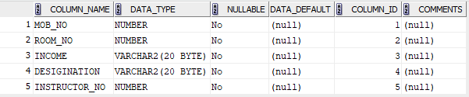

STUDENT
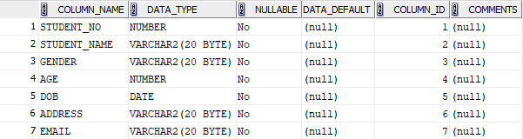

DEPARTMENT
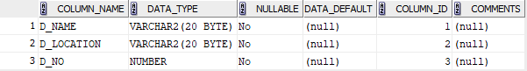

COURSE
