Arif Emre Çağlar
Independent Study
Report 1

Introduction
Lexical Semantics is a subfield of computational linguistics, which studies relationships between to words and how word contributes to the sentence that it resides in. The required information for the semantics of the word can be acquired from a text corpus, for example, the relationship between “wood” and “carpenter” can be determined by looking at the context that these words appear in several document instances.
A) WordNet
Lexicon is a term which corresponds to word lists with some subset of information, such as parts of speech. WordNet is a project first appeared in 1990, which is a big lexicon with properties of a semantic net. The WordNet's semantic net includes the following relations; synonymy, polysemy, metonymy, hyponymy/hyperonymy, meronymy, and antonymy as well as the new additions such as groups of similar words, links between derivationally and semantically related noun/verb pairs.
Relations in WordNet
Synonymy corresponds to the relationship of synonyms, which are different ways of expressing related concepts such as “gathering” or “meeting”. However, they are rarely substitutable, meaning we can not use them interchangeably in all contexts.
Homonymy corresponds to the words that have same syntax but unrelated meanings. On the other hand, polysemy corresponds to the words that have same syntax and have related meanings.
Metonymy is using an aspect of a word to describe something similar. Using the word “Ankara” in news to indicate “the Grand National Assembly of Turkey” might be an instance.

Hyponymy/hyperonymy corresponds to the “is-a” relationship. For example, polygamy (having more than one spouse at a time) is a hypernym of polygyny (having more than one wife at a time). And polygyny is hyponym of polygamy.
Meronymy corresponds to the relation between words where one is part of another, such as the relationship between “bird” and “wing”.
Antonymy corresponds to the relation between lexically opposite words such as “big” and “small”.
Using WordNet for Finding Similarity
The similarity between two words using WordNet can be calculated by counting the edges of the hierarchy and scaling it. The two formulas related are;
Leacock and Chodorov:
d(c₁,c₂) = 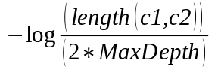
Wu and Palmer
d(c₁,c₂) = 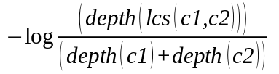
Advantages and Disadvantages
Using WordNet can be tempting because it is widespread, maintained and developed by researchers, and offers free software for helping. However, it is still incomplete, the length of the paths in hierarchies are irregular, and we can not relate the words that are not in same hierarchy such as “player”,”ball”, and the “net”.

B) Learning Similarity from Corpora
Clustering
Clustering is a common technique that is used to partition similar objects into different subsets. The algorithms that implement clustering can be hierarchical or partitional. Hierarchical clustering algorithms finds successive clusters using previous clusters, whereas partitional clustering algorithms finds all clusters at once.
a) Hierarchical Clustering
The measure that is used for defining similarity between two objects is called distance measure. The Euclidian Distance or Cosine Distance can be used as a distance measure algorithm. They both represent a word as a vector in a space.
Euclidian Similarity Measure:
The Euclidian Measure uses the Euclid formula that calculates the distance between two points. In the Figure below, the columns represents the words that their relations are to be queried, whereas rows represent the context of the data. For example, the intersection of Soviet row with the cosmonaut column indicates that cosmonaut word occurred in the Soviet context. The euclidian distance measure is calculated by the formula that resides in the Figure.
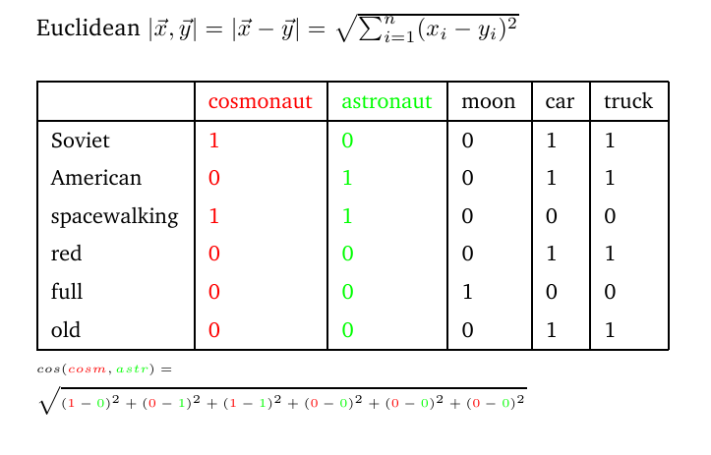
Cosine Similarity Measure:
In this measure, a word is represented by a vector. The result that is calculated is analogous to the angle between two vectors (or words). The formula for the measure is;
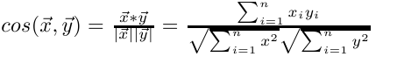

if cosine value happens to be 1, then the angle between vector x and vector y is 0 degrees, which implies vectors are same, and numbers closer to 1 implies that x and y are highly similar.
Information Theory(From wk05.pdf file)
Entropy: Quantifies the information in a probability distribution. It gives an idea about how random is the distribution (higher entropy -> uncertain), and it is measured on bits.
The optimal code assigned to a distribution P(X = x)= p(x) is the code word of length -log₂ p(x).
- Suppose the distribution of the 3-sided biased coin is p(a) = ½ , p(b) = p(c) = ¼. Then, the optimal code might be;
C(a) = 1, C(b) = 00, C(c) = 01
Therefore, entropy H(p) of a random variable X is the expected length of an optimal encoding of X.
H(p) = E[-log₂p] = −∑_{x} p(x) log₂p(x)
If we want to find the entropy of a fair die, p(1)=....=p(6) = 1/6 , then;
H(p) = - 6 * 1/6 * log₂(1/6) ≈ 2.58 bits.
Cross Entropy:
Cross entropy of a pair of random variables X,Y where P(X=x) = p(x) and P(Y=Y) = q(x) is the expected number of bits to encode X using an optimal code for Y. The equation for cross entropy is;
H(p || q) = E_{p}[-log₂q] = −∑_{x} p(x) log₂q(x)
In general H(p || q) ≠ H(q || p).
The Kullback-Leibler Divergence:
The Kullback-Leibler Divergence between two random variables X and Y is the expected number of bits lost in encoding X using an optimal code for Y. The equation for Kullback-Leibler Divergence is;
D_{KL}(p || q) = - E_{p}[-log₂q] – E_{p}[-log₂p] = E_{p}[log₂(p/q)] = ∑_{x} p(x) log₂(p(x)/q(x)) = H(p||q) – H(p)
D_{KL} is not a distance metric and generally D_{KL}(p || q) ≠ D_{KL}(q || p)
Joint-Entropy:
The joint entropy of a pair of random variables X,Y is the entropy of the joint distribution Z=(X,Y) where P(Z) = P(X=x, Y=y) = r(x,y)
H(Z) = H(r(x,y)) = -E_{r}[-log₂r(x,y)] = ∑_{x,y} r(x,y) log₂r(x,y)
- If X and Y are independent then H(Z) = H(X) + H(Y)
Conditional Entropy:
Conditional entropy of a pair of random variables X,Y is the amount of information needed to identify Y given X, where P(X=x,Y=y) = r(x,y)
H(Y|X) = H(X,Y) – H(X) = H(r) – H(p) where p(x) = ∑_{y}r(x,y)
Mutual Information:
Mutual information I(X,Y) is the amount of shared information between X and Y.
I(X, Y ) = H(X ) − H(X |Y ) = H(Y ) − H(Y |X )
= H(X ) + H(Y ) − H(X, Y )
= ∑_{x,y} r(x,y) log₂[ r(x,y) /(p(x) . q(y))]
where;

P(X = x, Y = y ) = r(x, y )
P(X = x) = p(x) = ∑_{y} r(x, y )
P(Y = y ) = q (y) = ∑_{x} r(x, y)
Agglomerative Hierarchical Clustering
Agglomerative clustering builds the clusters from pieces and the representation of this hierarchy is usually a tree structure. Suppose that items {a},{b},{c},{d} are to be merged and the measure is euclidian distance measure.
Suppose the two closest elements are {b} and {c}. The agglomerative algorithm chooses first {b} and {c} to be merged. Then, out items become {a},{b , c},{d}. Moreover, we want to merge further. To do this, we must find the distance between {a} and {b , c} clusters. Some options regarding to calculate the distance between two clusters is;
- Maximum distance between elements of each cluster. (O(n²logn))
- Minimum distance between elements of each cluster. (O(n²))
- The average distance between elements of each cluster.
- The sum of all intra-cluster variance.
- the increase in variance for the cluster being merged.
Each agglomeration occurs at greater distance between clusters than the previous agglomeration, and clustering needs to be stopped by looking one of these two criterias;
1) Distance criterion: When the clusters are too far apart, then clustering stops.
2) Number criterion: When there are sufficiently small number of clusters, than clustering stops.

