Automatic Retrieval and Clustering of Similar Words – Dekang Lin

- Introduction
The meaning of an unknown word can be inferred from its context. The purpose of this paper is to present a method that identifies the similar words. Identifying similar words may lead to various applications such as automatic thesaurus construction, solving the problem of sparse data in statistical natural language processing.
In statistical language processing, when the frequency of a word does not give a reliable maximum likelihood estimation, its probability can be computed as the weighted sum of the probabilities of words that are similar to it, which gives better results than Backoff smoothing.
- Word Similarity
The measure used in this paper is defined to be the amount of information contained in the
commonality between between the objects, divided by the amount of information in the descriptions of the objects.
A broad-coverage parser is used to extract dependency triples, which consists of two words and a grammatical relationship between them, from the text corpus. An example given in the paper is parsing of “I have a brown dog”:
Triplets: (have subj I), (I subj-of have), (dog obj-of have), (dog adj-mod brown),
(brown adj-mod-of dog), (dog det a), (a det-of dog)
Also, notation || w, r, w' || is used to denote the count of dependency triple (w, r, w'). When the one of the fields in the triple is a wild card (*), the frequency count is the some of all the frequency counts that matches the pattern. Moreover, description of a word w is all the dependency triples that matches the pattern (w,*,*), and the information contained in the description of a word is the sum of the information contained in each individual frequency count.
The measurement of the information contained in statement ||w,r,w'|| = c is the difference between:
- Amount of information in the statement that a randomly selected triple is (w,r,w') when we don't know the value of ||w,r,w'||.
- And the amount of information in the same statement when we do know the value of ||w,r,w'||.

Occurrence of (w,r,w') can be regarded as co-occurrence of the following events:
A: a randomly selected word is w;
B: a randomly selected dependency type is r;
C: a randomly selected word is w'.

When the value of ||w,r,w'|| is unknown, we assume that A and C are conditionally independent given B. The probability of A,B and C co-occurring is estimated by
P_{MLE}(B) P_{MLE}(A | B) P_{MLE}(C | B)
and
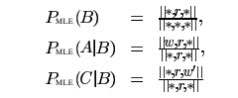

When the value of ||w,r,w'|| is known;
P_{MLE}(A,B,C) = ||w,r,w'|| / ||*,*,*||.
Given these, amount of information contained in ||w,r,w'|| = c, can be computed as follows;
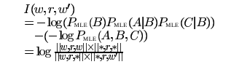

And I(w,r,w') is equal to the mutual information between w and w'.
Given T(w) is the set of pairs (r, w') such that I(w,r,w') is positive, the similarity function equation is;
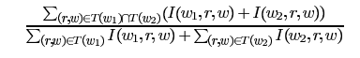
sim (w₁,w₂) =

Evaluation, Future Work, Related Work omitted.

