5- Word Vectors and Search Engines
  - – Journeys in the Plane
Vector spaces are linear, therefore we can show that a + b = b + a graphically in the 2-dimensional
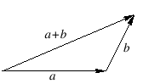
vector space, where a and b represents two 'journeys' in a plane.
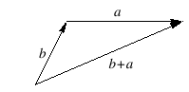
The operation of a+b or b+a is called vector addition. '+' is called an operator.

Definition 11: A mathematical operator, '*' is commutative, if a * b = b * a for all a,b.

Scalar Multiplication: Scalar multiplication of a vector gives the same direction as the original vector,
but of different length.
  - – Coordinates, bases, and dimensions
We can give each journey a set of coordinates, which breaks down the journey in different
components and different directions.
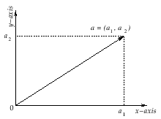
a₁ is said to be the x-coordinate of point a, a₂ is said to be the y-coordinate of point a, where point a is defined as “journey from 0 to a”.

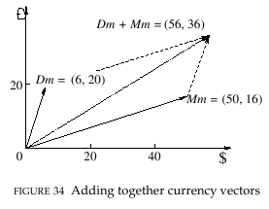
Addition of the two vectors using parallelogram rule.

Definition 12: The dimension of a vector space is the number of coordinates needed to uniquely specify a given point.
  - – Search Engines and Vectors
The early search engines relied on simple 'term matching' where they returned the documents
which includes the terms in the user's query. However, returning all the documents that match the user's query leaves the user with a mass of irrelevant documents. Therefore, a better measure of relevancy would be needed rather than simply dividing the documents by which contains the keywords and which have not.
One way to do this is to represent words as vectors. The coordinates of a vector is a measure for a particular word for how important that word for a particular document.
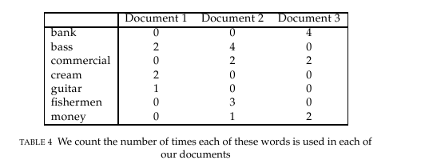
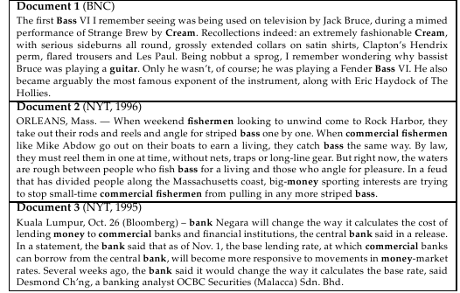
In this table for example, the word “bass” occurred 2 times in Document1, 4 times in Document2, and so on. However, this is only a fraction of a real term-document matrix. Normally, number of words or documents can be several millions. The documents that these statistics are taken is below;
These tables can be used as an inverted index. For example, if we want to find about money, these table tells to start from Document3, since it is mentioned twice from Document2. However, there are some problems with this idea;
- Many possible meanings are absent in this fragment. For example, bank can correspond to a river bank also.
- The term bass have more than one meaning in corresponding 3 documents. In the first document, it is an instrument, in the second, it is a kind of fish. Because it is unlikely that a user would be interested in both of the two meanings, how can we enable the users to search for documents containing a particular meaning?
- The term guitar only appears once in Document 1 — but it’s very possible that a user searching for the term guitar would also ﬁnd articles containing the term Les Paul relevant, since Les Paul is a make of guitar.
The solutions to these problems will be issued, but none of them are completely solved. To
come to our vector solution, we can think of each row as a vector, and some theory and techniques of vectors can be used to calculate and reason with words.
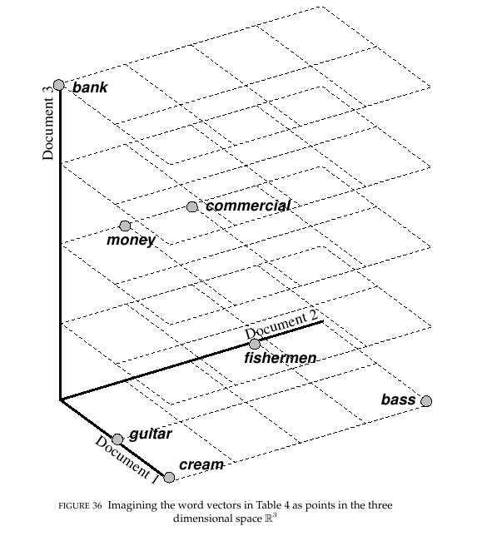
We can think of vectors in Table 4 as points in 3-dimensional space, because there are 3 documents specified. However, this is simply a visual aid, and all the things that we would do with vectors is about the coordinates in Table 4.
  - – Similarity and distance functions for vectors
This sections tells the most prominent ways to measure similarity and distance between vectors
with any number of dimensions and how to apply them to our word vectors. To start with an example, we can use word vectors from Table 4.
bank = (0, 0, 4), bass = (2, 4, 0) and money = (0, 1, 2).
In order to measure similarity between two words, we can multiply each component of a vector separately and add them. For instance, to obtain a similarity score between bank and money;
sim(bank, money) = (0 × 0) + (0 × 1) + (4 × 2) = 8.
Using the same measure, similarity between bass and money is;
sim(bass, money) = (2 × 0) + (4 × 1) + (0 × 2) = 4.
Intuitively, this measure says that bank and money are most similar, and bass and money are less similar but not unrelated. To explain this, we can say that the score came from Document2, which discusses about the financial interests behind bass fishing.
However, there are some drawbacks of this method. For example, given vectors guitar = (1,0,0) and cream = (2,0,0), the similarities for cream is always the double of the similarities for guitar, but it seems wrong.
    - – Introducing vector space R^{n}.
In our word vectors, each vector is a point in the 3-dimensional space. The space of all possible
collections of 3 real numbers is given the name R³. This idea can be generalized as follows;
Definition 13: The vector space R^{n} is made up of all the lists of the form (a₁,a₂,...,a_{n}), where each of the entries are real numbers.
By definition, each point in R^{n} has n coordinates, so its dimension is n. Addition and scalar multiplication of vectors is defined as we would expect;
(a₁ + b₁ , a₂ + b₂ , . . . , a_{n} + b_{n} )
and
(λa₁ , λa₂ , . . . , λa_{n} ).

    - – Scalar product of two vectors.
The calculation above used for similarity actually represents the scalar product between two
vectors. It is formally defined as follows.
Definition 14: Let a = (a₁ , a₂ , . . . , a_{n} ) and b = (b₁ , b₂ , . . . , b_{n} ) be vectors in R^{n} . Their scalar product a · b is given by the formula;
a · b = a₁ b₁ + a₂ b₂ + . . . + a_{n} b_{n} .
    - – Euclidian distance on R^{n}. Extending Pythagoras' theorem to n dimensions.
The formula of the Euclidian distance for n-dimensions is below. It is the extension of the Pythagoras' theorem to n dimensions.
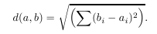

This same notation can be used to represent the scalar product of two vectors as follows;

The vectors in Table 4 again used as an example to show Euclidian distance measure. The vectors again are;
bank = (0, 0, 4), guitar = (1, 0, 0) and money = (0, 1, 2).
Applying Euclidian distance formula, the distance between bank and money is;
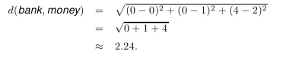

where as the distance between bank and guitar is;
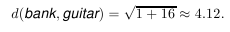

The intuition of these results is “bank” is more closer to money, and it is more distant than “guitar” as we would expect.

The problem is large vectors (in terms of magnitude) are more distant than smaller vectors. For example;

The distance between guitar and fishermen is closer than the distance between guitar and bass. This is not because guitar and fishermen have more in common. This is because they are both nearer to origin.
    - – Choosing norms and unit vectors.
It is shown that working with Euclidian distance and scalar product are not the ideal ways for
working out similarities. In Euclidian distance, frequently occuring words with large word vectors tend to be too far from each other, and in scalar product, the same frequently occuring words tends to be too similar to most other words. Therefore, we must factor out all the unwanted advantages and disadvantages.
To do this, we first calculate the size or length of each vector from the origin by applying the Euclidian formula to the vectors 0 = (0 , 0 , ... , 0) and a = ( a₁ , a₂ , ... , a_{n}). Then we have,
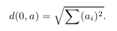
Notice that we can express this in terms of scalar product. More formally in the following definition.

Definition 15: The norm or length of the vector is defined to be;
This norm can also be defined as the Euclidian distance between two vectors as || b – a ||.
We use the norm to divide the vector to factor out extra preference or penalty given to any word vector. This vector is written by a / || a || and is called as unit vector of a. We can visualize it by looking at the following figure.
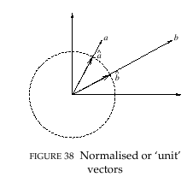

The Table 5 below is the normalized form of Table 4, which each column is divided by the length of the corresponding row. To see that they are unit vectors, we can square each number in a row and add them, and the length that is the outcome of this calculation is 1.
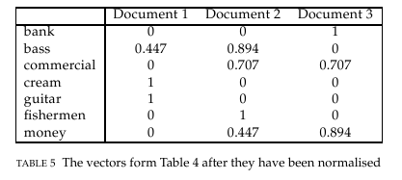

    - – Cosine Similarity in R^{n}.
Cosine similarity is the scalar product of two normalized vectors. The cosine similarity of any pair
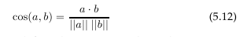
of vectors is obtained by first taking the scalar product and then dividing to their norms, rather than normalizing all vectors first and then computing cosine similarities of these normalized vectors. Thus, the formula is;

It is also useful to think this formula's outcome as the cosine of the angle between two vectors, meaning the closer the outcome to 1, the more similar are the vectors.
So we can obtain a table which shows the similarities between word pairs. These tables are called data matrix or adjacency matrix. We can also note that the table below is symmetric.
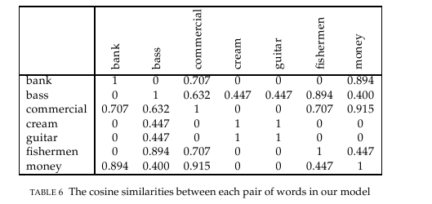
  - – Document Vectors and Information Retrieval.
Because the search engines returns documents for queries, we need to include documents into this
with the notion of Document vectors. Its intuition is we represent the document lie in the same space with words, and then we can compute the similarities between words and documents with this notion. We can represent document vectors very simply as defining it a unit vector in the direction of its coordinate axis. In our 3-dimensioned example, the document vectors are;
Doc1 = (1, 0, 0) , Doc2 = (0, 1, 0) , Doc3 = (0, 0 ,1).

Now we can compute the cosine similarity between a query and each document. For example, for the query bass with vector (0.477, 0,894, 0) from Table 5 would give;
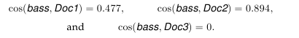

If the user sees the winning document Doc2 and realized that this is not the bass that he is looking for, he could add the term guitar to make the query bass guitar, then we can simply add the vectors bass and guitar. Then,
bass + guitar = (0.477, 0.894, 0) + (1, 0, 0) = (1.477, 0.894, 0),
which says that now the winning document is Doc1 with a cosine score of 1.477. By this way, we combined the meanings of two words to give a meaning to a combination of words, which is called semantic composition.

