This doc are some recommended resources for further research of the project.

1. RTMP Panoramic video player:

**Kapano** is a library which has the potential to live streaming panoramic video through RTMP protocol.

There are two posts on their official forum mention the possible set up:

<https://krpano.com/forum/wbb/index.php?page=Thread&threadID=14460>

<https://krpano.com/forum/wbb/index.php?page=Thread&threadID=6720>

However, since those posts are posted years ago, even if I follow the instructions, the whole set up doesn’t work on current version.

Kapano Javascript library: <https://krpano.com/download/>

The js file could be found at templates/xml/plugins

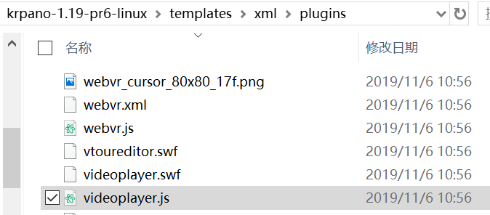

**Mxreality** is a panoramic vr player which is quite similar to the videojs-vr library we use, the github repository link is: <https://github.com/guoguicheng/mxreality.js>

1. Stream Server:

Wowza is a potential replacement for Nginx as streaming server.

It’s a professional business software for live video streaming. Download Link: <https://www.wowza.com/pricing/installer>

Official guide:

<https://www.wowza.com/docs/how-to-start-and-stop-wowza-streaming-engine-software#startServWin>

<https://www.wowza.com/docs/How-to-set-up-live-streaming-using-an-RTMP-based-encoder>

<https://www.wowza.com/docs/how-to-playback-with-the-example-adobe-flash-players-rtmp#play-a-live-stream>