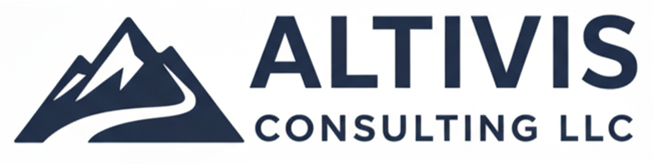

Capability Statement
Operations • S&OP • KPI Systems • Lean Process Improvement
Bill Clarke • bill@altivisconsulting.com • Denver, CO (Remote-first • On-site as needed)

Executive Summary
Altivis Consulting helps operations and supply chain leaders stabilize planning, improve execution, and build KPI visibility with practical systems that teams can run without heavy overhead. Engagements are designed to deliver measurable results in 4–12 weeks through hands-on working sessions, simple templates, and repeatable operating rhythms.
Core Services
S&OP and Planning System Design
- Design planning cadence, decision forums, and roles/responsibilities
- Align demand, supply, and finance with clear inputs/outputs
- Build capacity, inventory, and service-level visibility
KPI Systems & Operational Analytics
- Define action-driving KPIs (not dashboard clutter)
- Create lightweight reporting and review routines that teams actually use
- Improve visibility across throughput, service, backlog, inventory, and labor
Lean Process Improvement
- Identify bottlenecks, waste, and unstable processes
- Reduce cycle time and strengthen standard work
- Implement practical daily management and frontline problem solving
Ideal Clients
- Operations & Supply Chain leaders managing reactive execution
- Manufacturing and life sciences teams operating under compliance constraints
- Mid-market to enterprise organizations that need fast traction without a massive transformation
Selected Outcomes
- Scaled output ~400% by supporting production readiness and planning discipline during a high-growth ramp
- Reduced cycle time ~50% through lean and process improvement in regulated manufacturing environments
- Reduced distribution center inventory ~50% by improving replenishment signals and enabling automation
Engagement Approach (Typical 4–12 Weeks)
- Diagnose: quick discovery and data reality-check to pinpoint constraints and root causes
- Design: operating rhythm, planning model, KPIs, and templates tailored to your team
- Implement: working sessions + rollout support so the system sticks after handoff
About Bill Clarke
Bill Clarke is an operations and supply chain consultant with 12+ years of experience across manufacturing, planning, and life sciences. His background includes consulting and industry leadership roles, with a hands-on style focused on clarity, execution, and measurable outcomes.
Next Step
Book a free 20-minute Ops Triage: https://altivisconsulting.com
Email: bill@altivisconsulting.com

