Files and Folder structure for TREAT

TREAT workflow comprises of 5 different modules
- Quality Control
- Alignment
- Variant Calling
- Annotation and Reports
- Sample Statistics
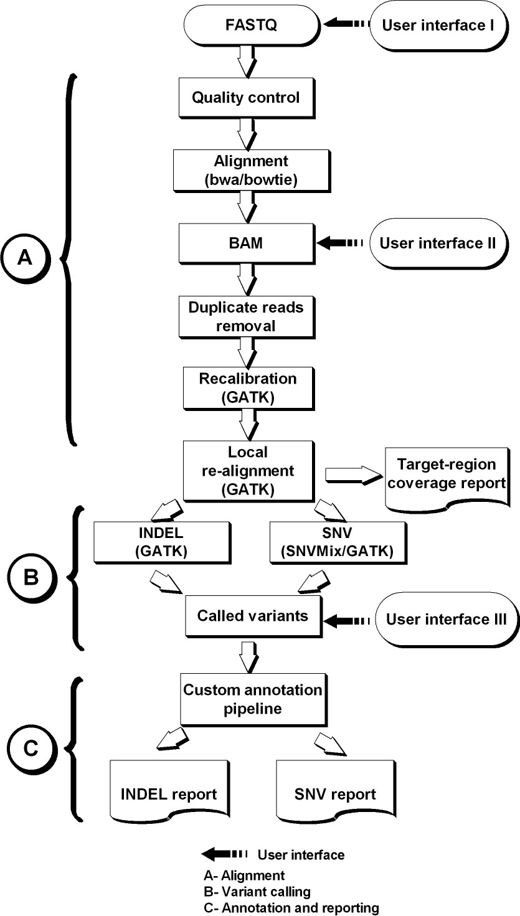

Analytic TREAT workflow for Exome Capture analysis

How to run the workflow

TREAT is a command line tool. Run treat.sh to get the usage information.
$ /path_to_workflow/treat.sh
Usage: <run_info file>

Before running the workflow user need to manually create three reference files and make sure the entire path to the various tools and references are correct and are according to the study.

- tool info file ( path to various tools and references)
- sample info file ( names for the fastq, BAM, variant files for all the samples)
- run information file ( includes meta data information and information about the run)

Examples for all the configuration files are located in the TREAT scripts folder. If user wants to run the TREAT for a sample data set then it is available for all the modules in:

\\rcfcluster-cifs\data2\bsi\RandD\sampleData_TREAT\

Quality Control

FASTQ

ILL2SANGER (quality conversion)

FASTQ

FASTQC (0.7.0)

FASTQ

Input:
Takes Fastq’s as input (all the Fastq’s should be in same folder)

Quality control step:

- Check if Quality scores in fastq are Illumina or Sanger, if it is Illumina then convert the scores to Sanger score
- Run FastQC on all the fastq’s provided
- If we already have FASTQC results then there is a flag in run info file which can checked as NO and specify the folder for FASTQC results.
- If conversion is not required then the original fastq’s are sub linked to the fastq folder.

Output:
Converted fastq

Folders created:

<output_folder>
| _ <fastq>
| _ <sample.fastq>
| _ <fastqc>
| _ <sample fastqc results>
| _fastqc_report.html

Potential Use of data:
FastQC aims to provide a simple way to do some quality control checks on raw sequence data coming from high throughput sequencing pipelines. It provides a modular set of analyses which you can use to give a quick impression of whether your data has any problems of which you should be aware before doing any further analysis. It runs a series of tests and will flag up and potential problems with your data

Alignment

FASTQ

BWA (0.5.9)/BOWTIE (0.12.7)

BAM

Remove Duplicates PICARD (1.47)

BAM

Input:
Takes Fastq’s as input (all the Fastq’s should be in same folder)

Output:
Sorted and indexed BAM

Folders created:
Output_folder/alignment
Consist of a folder for each sample which contains the sorted and index bam file for that sample

<output_folder>
| _ alignment
| _ sample1
| _ sample-sorted.bam
| _ sample-sorted.bam.bai
| _ sample.flagstat
| _ sample.dup.txt
| _ sample2

Useful files:
alignment/Sample/sample-sorted.bam
alignment/Sample/sample-sorted.bam.bai
(Unfiltered BAM; contains all the reads (aligned and unaligned)

Potential Use of Intermediate data:

- In Run info file there is a flag which helps TREAT to decide whether study needs remove duplicate or not

MARKDUP=YES/NO

- Extract Fastq
/data2/bsi/RandD/exome/bam2fastq/bam2fastq.sh
Usage: for PE: bam2fastq.sh <input bam>(provide full path) <name for read1> <name for read2>
for SR: bam2fastq.sh <input bam>(provide full path) <name for read1>

- To get the alignment numbers
There is a file named sample.flagstat which gives out alignment numbers such as number of reads, mapped reads etc.

- To get information about the BAM
samtools view -H output_folder/alignment/sample/sample-sorted.bam
@SQ SN:chrM LN:16571
@SQ SN:chr1 LN:247249719
@SQ SN:chr2 LN:242951149
@SQ SN:chr3 LN:199501827
@SQ SN:chr4 LN:191273063
@PG ID:bwa PN:bwa VN:0.5.9-r16
@PG ID:BWA
@RG ID:6-HBPN-Land-JL SM:6-HBPN-Land-JL LB:/data1/bsi/refdata/bictools/sequence/human/ncbi/36.49/indexed/BWA_Indexed_reference_including_ChrM/allChr.fa PL:illumina CN:MAYO

Variant Calling

BAM

GATK

Recalibrated and Realigned BAM

GATK/SNVmix

Raw and Filtered Variant calls

Target Kit provided

OnTarget Variant Calls

Input:
Sorted and indexed BAM from the alignment module or if user wants to use BAM as an input to the workflow then user inputted BAM. To reduce the computational time we chop the BAM into per chromosome and execute whole module in parallel for each chromosome.

NOTE: Now we use bigger target region which includes the entire coding region merged with the capture kit used for sequencing. The bigger target region is used when we generate variant calls not for the pileup and bam intersect as if we use bigger target region then the results for the coverage analysis is not appropriate.

Output:
OnTarget variant calls

Folders created:
Output_folder/realignment
This folder contains per sample folder, which includes per chromosome realigned and recalibrated and indexed BAM obtained using GATK.

<output_folder>
| _ realignment
| _ sample1
| _ chr*-sorted.bam
| _ chr*-sorted.bam.bai
| _ chr*.pileup
| _ chr*.flagstat
| _ sample12

Useful files:
realignment/Sample/chr*-sorted.bam
realignment/Sample/chr*-sorted.bam.bai
realignment/Sample/chr*.pileup

Output_folder/variants
Folder contains all the per chromosome raw and filtered variant calls per sample.

<output_folder>
| _ variants
| _ SNV
| _ sample.chr*.snvs.raw.snvmix / sample.chr*.snps.raw.gatk.vcf
| _ sample.chr*.raw.snvs
| _ INDEL
| _ sample.chr*.indel.gatk.vcf
| _ sample.chr*.raw.indels
| _ logs

Useful files:
- output_folder/variants/SNV
Folder contains raw and filtered per chromosome variant calls for each sample
RAW
sample.chr*.snvs.raw.snvmix / sample.chr*.snps.raw.gatk.vcf
FILTERED
sample.chr*.raw.snvs
- output_folder/variants/INDEL
RAW
sample.chr*.indel.gatk.vcf
FILTERED
sample.chr*.raw.indels

Output_folder/OnTarget
Folder contains OnTarget variant, pileup and BAM

<output_folder>
| _ OnTarget
| _ sample.chr*.raw.snvs.bed.i.ToMerge
| _ sample.chr*.raw.indels.bed.i.ToMerge
| _ sample.chr*.pileup.bed.i
| _ sample.chr*.cleaned-sorted.bam.i
| _ logs

Useful files:
- OnTarget SNVs
sample.chr*.raw.snvs.bed.i.ToMerge
- OnTarget INDELs
sample.chr*.raw.indels.bed.i.ToMerge
- OnTarget Pileup
sample.chr*.pileup.bed.i
- OnTarget BAM
sample.chr*.cleaned-sorted.bam.i

Output_folder/realigned_data
This folder contains per sample folder, which includes realigned and recalibrated and indexed BAM for IGV visualization obtained using GATK

<output_folder>
| _ realigned_data
| _ sample1
| _ sample.igv-sorted.bam
| _ sample.igv-sorted.bam.bai
| _ sample2

Useful files:
realigned_data/sample/sample.igv-sorted.bam

Filters Used:
- Realigned and recalibrated BAM are filtered with quality (MAPQ >= 20)
- filtered SNVs
  - mapping and base quality >=20
  - probability >= 0.8
  - Reference Homozygous calls thrown out

Potential Use of Intermediate data:
- Intermediate raw variants calls to change the default filtering criterion purely study specific
Raw files can be obtained from output_folder/variants/ and description of the file names is stated above.

- To know how realignment and recalibration helps
In output_folder/realignment each sample contains chr*.flagstat files which has mapping numbers after realignment.

- Interested in knowing the coverage on the Target regions
In output_folder/OnTarget each sample has OnTarget BAM’s and Pileup and expected file names are described above.

Annotation and Reports

OnTarget Variant calls

SIFT / SSEQ / MAYO ANNOTATION

Merged and per sample Reports

Input:
OnTarget variant calls for each sample

Output:
Merged and per sample reports and variant distance for unique variants over all the samples

Folders created:
Output_folder/annotation
Folder contains annotation from SIFT and Seattle Seq

<output_folder>
| _ annotation
| _ SIFT
| _ siftids
| _ sift.out.allsamples.chr*.merge
| _ sample.chr*.raw.snvs.bed.i.ToMerge.sift
| _ sift folder (per chromosome per sample)
| _ SSEQ
| _ sample.chr*.snv.sseq
| _ sample.chr*.indels.sseq
| _ sseq.snvs.out.allsamples.chr*.merge
| _ sseq.indels.out.allsamples.chr*.merge
| _ logs

Useful files:
- output_folder/annotation/SSEQ
This folder has per chromosome Seattle seq results for each sample
sample.chr*.snv.sseq and sample.chr*.indels.sseq
And this folder also contains merged Indels and SNVs annotation form Seattle seq for each chromosome which is used to create merged report
sseq.snvs.out.allsamples.chr*.merge and sseq.indels.out.allsamples.chr*.merge
- output_folder/annotation/SIFT
This folder has per chromosome SIFT annotation. When we run SIFT it gives out a number to a folder where it stores the annotation which we record in a file names siftids in the same folder so as to track which folder belongs to which set of variants. The merged sift annotation per chromosome are alos listed as sift.out.allsamples.chr*.merge

Output_folder/TempReports
This folder contains all the temporary files generated during adding columns to the OnTarget variant calls for various annotations. Used mainly to debug if something went wrong during the analysis

Output_folder/Reports
Folder contains Merged INDEL and SNV reports with variant distance fro the splice sites for INDELs and SNVs. For variants there are two reports we deliver i.e. Unfiltered and filtered

<output_folder>
| _ Reports
| _ *.cleaned_annot.xls
| _ *.cleaned_annot_filtered.xls
| _ *.report
| _ *.cleaned.report
| _ variantLocation_INDELs
| _ variantLocation_SNVs

Useful files:
SNV SNV.cleaned_annot.xls (file) and SNV.cleaned_annot_filtered.xls (file)
INDEL INDEL.cleaned_annot.xls (file) and INDEL.cleaned_annot_filtered.xls (file)

Output_folder/Reports_per_Sample
Folder contains per sample INDEL and SNV reports (filtered and unfiltered)

<output_folder>
| _ sample.*.report
| _ sample.*.cleaned.report
| _ sample.*.cleaned_annot.xls
| _ sample.cleaned_annot_filtered.xls

Useful files:
SNV sample.SNV.cleaned_annot.xls (file) and sample.SNV.cleaned_annot_filtered.xls (file)
INDEL sample.INDEL.cleaned_annot.xls (file) and sample.INDEL.cleaned_annot_filtered.xls (file)

Filters Used:
- Used to create the Filtered Reports (merged and per sample)
  - dbSNP130 column does not have an rs ID (novel), OR
  - functionGVS column having 'missense', 'nonsense', 'splice-3', 'splice-5', 'coding-notMod3', 'utr-3' or 'utr-5' (intron, intergenic and coding-synonymous removed using SeattleSeq annotation - (http://gvs.gs.washington.edu/GVS/HelpSNPSummary.jsp)), OR
  - any variant reported within +/-2bp of an exon edge using 'distance' report for variants
- Only OnTarget variant calls are annotated

Potential Use of Intermediate data:
- Merged and Per sample reports for tertiary analysis
Results can be found in Reports and Reports_per_Sample folder

- Above files can be used to filter the number of candidate variants by looking at the functional GVS from Seattle seq column in the reports

- Detailed column description can be found in Output_Folder/ColumnDescription_Reports.xls for SNVs and INDELs

Sample Statistics

Input:
All the modules completed

Output:
It gives out the quantitative analysis for all the samples.

Folders created:
Output_folder/numbers
Folder contains two files per sample to be used to generate HTML report

<output_folder>
| _ numbers
| _ sample.out
| _ sample.coverage.out
| _ logs

Useful files:
- Contains mapping numbers, annotation numbers, variant numbers, etc.
sample.out
- Contains numbers for coverage at 1 to 40X
sample.coverage.out

Folders and Files to deliver to PI
The list of files and folders to transfer to the windows share to deliver to PI

<output folder>
| _ Main_Document.html
| _ Coverage.JPG
| _ exome_workflow.JPG
| _ igv_session.xml
| _ IGV_Setup.doc
| _ SampleStatistics.tsv
| _ StatiticsDesciption.html
| _ ColumnDescription_Reports.xls
| _ Reports_per_Sample
| _ sample.SNV.cleaned_annot.xls
| _ sample.SNV.cleaned_annot_filtered.xls
| _ sample.INDEL.cleaned_annot.xls
| _ sample.INDEL.cleaned_annot_filtered.xls
| _ Reports
| _ SNV.cleaned_annot.xls
| _ SNV.cleaned_annot_filtered.xls
| _ INDEL.cleaned_annot.xls
| _ INDEL.cleaned_annot_filtered.xls

Points to remember:

- Do the spot checking described in the file before delivering the results
- Charge 4 hrs to run Workflow from sequencing core or charge 6 hrs. to run workflow for external data
- Update the project tracking sheet with task details and other information
- Include Sumit and Jane in all the emails
- Follow the folder structure on windows share.
- After the completion of workflow, user needs to run clean space command which deletes all the intermediate files.
$TREAT_PATH /cleanspace.sh
Usage: <input dir full path>

Potential Use of Intermediate data:
- Used to create HTML report, named as Main_Document.html can be found in $output_folder. This report is an intuitive way to summarize all the findings during the analysis.

- To get the plot for coverage analysis.

- Statistical Summary Tables:

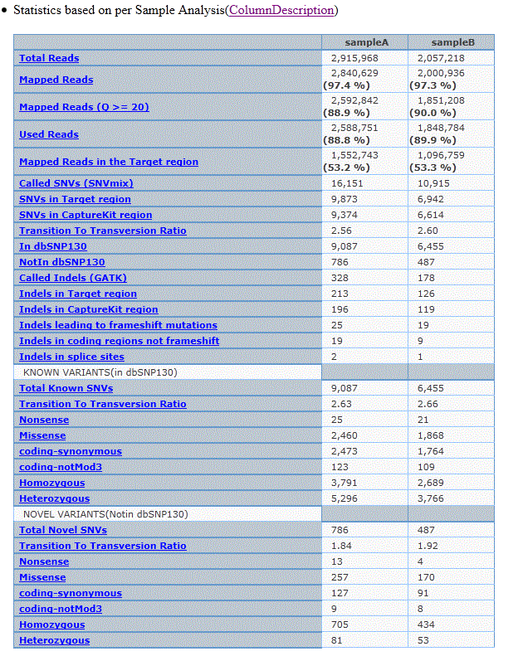

- Expected Reports format with column descriptions

INDEL REPORT

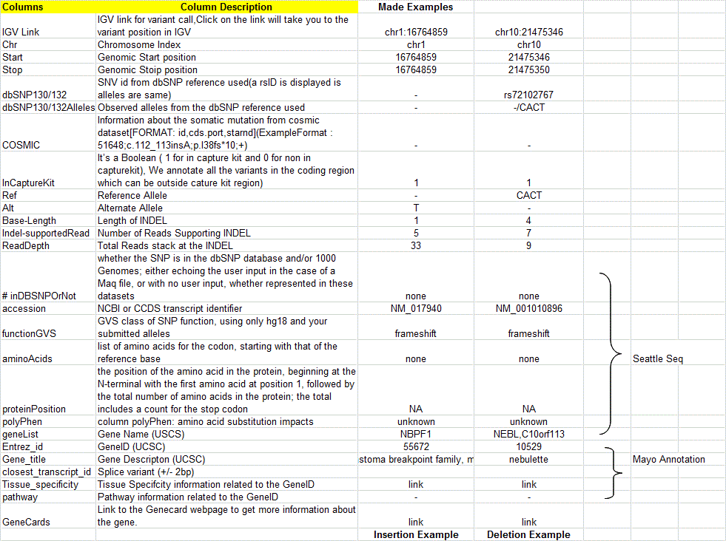

SNV REPORT

