

Mini Project #2: Bridge Design

Group 10: Omega
Date: 17/05/2022
Course: MIET2499 – Stress Analysis
Lecturer: Dr. Nguyen Chi Trung
Team Members
Nguyen Hoang Long – s3697382
La Minh Thuan – s3877847
Ha Hoang Phuc – s3748017

Contents
Introduction & Theory 3
Project Overview 3
Equipment’s 3
Theory Overview 3
Knowns and unknowns 6
Error Sources 6
Constraints: 7
Suggested Solution 7
Design Proposal and Analysis 8
Design overview 8
Bill of Materials 8
Structure analysis 9
Design Load Cases 10
*Load case 1: 10
Maximum Stress Analysis 10
Deflection Analysis 12
*Load case 2: 14
Maximum Stress Analysis 14
Deflection Analysis 15
*Load case 3: 16
Maximum Stress Analysis 16
Deflection Analysis 17
Conclusion 18

Introduction & Theory

Project Overview
A bridge is a structure whose purpose is to allow its users to cross large chasms with ease, saving significant time while staying safe during their travels. This project aims to study the loading conditions of a single segment of a bridge under load, from which students can plan the bridge’s design specifications in order to meet the assignment requirements (maximum deflection being 5mm). More specifically, students are tasked to design and implement modifications to an existing bridge deck, implementing supports and reinforce key areas to ensure stability in the bridge to sustain worst-case loading scenarios while having a safety factor of 1.5. This report will go into detail about our design philosophy and explain certain key specifications such as worst-case loading scenarios, internal shear/moment diagrams and what we have done to adjust for these worst-case conditions.

Equipments
With this mini project surrounding the 600x100x3mm PMMA (Acrylic) beam acting as the bridge’s deck; The following are the equipment’s relevant to the design of this bridge:
- Hand Clamps - Used as a fixed support for the bridge at the 100mm mark of the provided PMMA deck.
- Laser Cutter in RMIT’s AM Lab - further manufacture parts to strengthen the deck of the bridge.
- PASCO 1.2m Dynamic Track [] - This is used to connect seamlessly with the students’ designed bridge to conduct the experiment.
- PAScars and its 8kg load [] - Used to apply loading conditions on the bridge and to simulate traffic traversing the bridge.
- PASCO Physics strings [] - Used to wrap around a circular pulley to provide a linearly applied force on the load.
- PASCO foam pads [] - used as a safety measure should the experiment fails and the PAScars fall into the 500mm chasm to minimize the probability of injury or damage of equipment/property.
- Digital caliper [] – used to measure the deflection and other dimensions.

Theory Overview
The knowledge delivered throughout the MIET2499 course is applied to this project to design and build a complete bridge that satisfies the mentioned requirements. These theoretical concepts are listed below
- Moment bending stress and longitudinal shear stress: The transverse loads across the bridge beams would cause direct loadings and moments, which may fail the bridge at the worst cases.
- Shear and moment diagram: To illustrate Shear Forces and Moments along the design, which helps us find the worst-case scenarios and thus, plan the bridge’s design.
- Elastic curve equation: To calculate the deflection along the beam, which also derives the maximum deflection at specific location on the beam. Furthermore, an elastic curve graph can be illustrated from this equation.
- Beam type and deformation: Different types of beam yield different moments of inertia, hence different deformations. In this project, I beam is chosen and assembled to achieve best outcomes.

The theoretical principles that are applied in this project to analyze the loading conditions traversing along the bridge and design that bridge such that it can bear that loading are present as follows:
*Centroid (neutral axis) of the whole bridge structure from the top or bottom:
$$\overline{y}=\frac{(Σ yA)}{(ΣA)}$$
Y(m) = distance from the centroid of the part to the top (or bottom) of the cross section
A($m^{2})$= the area of the of the part
* Second Moment of Inertia with parallel axis theorem of the combined structure of rectangular parts:
$$I_{x}=Σ(\frac{bh^{3}}{12}+Ad^{2})$$
b(m) = the base of the rectangular part
h (m) = the height of the rectangular part
A ($m^{2})$ = the area of the rectangular part
d (m) = the distance between the neutral axis to the centroid of the rectangular part
*Bending moment is related to the stress distribution within the beam acting on its cross-section via the flexure formula:

$$σ_{bending}=-\frac{My}{I}$$
$$y (m)= the distance from the neutral axis to a point on the section$$
$$M(Nm)= the internal bending moment about the section^{'}s neutral axis$$
$$I(m^{4})=the moment of inertia of the section area about the neutral axis$$
*First moment of Inertia:
𝑸= 𝒚′𝑨′
𝒚′(m) = the distance from the neutral axis to the centroid of 𝐴′.
𝑨′ ($m^{2})$ = the area of the top (or bottom) portion of the member’s cross-sectional area, above (or below) the section plane where 𝑡 is measured.

*The beam develops longitudinal shear stress due to the shear force from the loadings and the beam design including moment of inertia I, first moment Q and the section t
𝝉 =$\frac{VQ}{It}$
𝝉(Pa) = the shear stress in the member at the point located a distance 𝑦 from the neutral axis of the cross-section. Assumed to be a constant.
𝑽 (N) = the internal resultant shear force, determined from the method of sections and the equations of equilibrium.
𝒕 (m) = the width of the member’s cross-sectional area, measured at the point where 𝜏 is to be determined.
*The safety factor is the ratio between the theoretical stress and allowable stress, to prevent the beam to collapse when it reaches the maximum calculated stress:
$$S.F=\frac{σ_{y}}{σ_{allow}}$$
$$σ_{y}(Pa)=the yield strength of the material$$
$$σ_{allow}(Pa)=the allowable stress of the material$$
*The curvature of the bridge relates to the bending moment M and the flexural rigidity EI by this equation:
$$\frac{1}{ρ}=\frac{M}{EI}$$
$$\frac{1}{ρ}=curvature of the bridge$$
$$E (GPa)=Modulus of elasticity of the material$$
*The elastic curve equation plots the deflection of the bridge under effects of loadings, in which the maximum of deflection is no more than 5mm in this project. This equation also proves that the height of the beam affects the performance of the bridge via the moment of inertia I
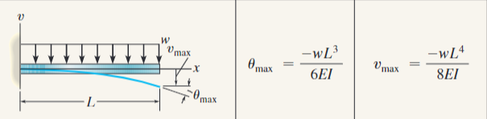

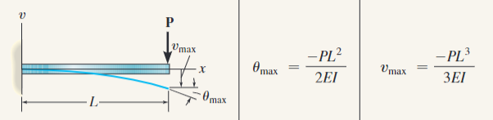

Knowns and unknowns
In this project, the knowns can be deduced from the requirements and given materials such as
- The bridge deck is 600x100x3mm and a total of 3000$cm^{2}$ of material, all made of acrylic. The specification for acrylic material is as follows: Modulus of elasticity: E = 1800MPa (worst case) and tensile yielding stress: $σ_{y}$= 48MPa (worst case).
- The bridge length is 500mm, the thickness of any part is 3mm.
- The combined loading is 8kg, with a safety factor of 1.5.
- The maximum deflection is 5mm with only one fixed support at one end.
- The distance between two PAScar tires is 10.3cm, and the distance between two tires of different PAScars is 6.8cm. This data is acquired by manually measuring the PAScars at the lab.
From the above known factor, the calculation applying theoretical principles determines unknown factors, such as second moment of inertia, maximum bending moment/shear force, cross-sectional area and real maximum deflection. It is necessary to analyze the relationship between those factors such as
- The shear force versus bending moment diagram via equilibrium equations
- The cross-sectional area of the designated bridge affects the moment of inertia.
- The present loads on the bridge affect both bending moment and shear force.
- Modulus of elasticity, moment of inertia and loads directly affect the result of maximum deflection from the curve elastic equations.

Error Sources
There are some potential sources of error in this project. Firstly, the manufacturing process (laser cutter) has about 5% error, which should be addressed in the calculation process by using three decimal digits. Besides, having a second manufacturer to provide another sample helps in case of manufacturing devices failure in the first one.
Secondly, the discrepancy between the theoretical and experimental results. During the calculation process, several assumptions are made, such as the material of the bridge is both homogeneous and isotropic, that is, it has the same physical and mechanical properties throughout its volume, and it has the same properties in all directions. Those may not be true and can lead to the crack at some points inside the bridge.
Lastly, about the miscalculation in the design process, one wrong calculation can lead to severe breakdown of the bridge in experimental tests. Only way to solve this problem is to double-check every step and revise with other professionals.

Constraints:
There are three important constraints that need to be considered in this project. The first one is the length of the beam, which is fixed at 500mm. The length affects the curve equation when applying the distributed load at later calculations in the design process. The second constraint is the bridge material, which is meant to be acrylic. Acrylic’s modulus of elasticity in the worst case is 1800MPa and tensile strength is 48MPa, which are needed when defining the bending moment. The last constraint is the fixed support at one end of the bridge while the other end is free, which makes the worst-loading scenario happen at the free end of the bridge and affects directly both the shear force and bending, shear stress and the maximum deflection.

Suggested Solution
- To achieve the project objectives, we need to make the design for the bridge by adding some parts under and above the given beam to reinforce the bridge’s deck. Then, we calculate the centroid and the second moment of inertia of the beam’s cross section. Next, we determine the beam’s deflection at the free end of the bridge and check if it is less than 5 mm as required or not. If not, we need to come up with a new design for the bridge until the calculated deflection of the beam meets the requirement. After deciding the design, we draw the shear-moment diagram to determine the maximum shear force and moment, then use them to calculate the maximum bending stresses and longitudinal shear stress. After the design has been finalized following the calculation process, the actual prototype is then fabricated, which then will follow the experiment/data collection procedure.
By placing two 1.2m PASCO tracks on either side of the prototype (having its first 100mm fixed using a hand clamp), 2 PAScars with a total load of approximately 8.6kg travel down its length both ways, whose deflection is then measured by utilizing a digital caliper.

Design Proposal and Analysis

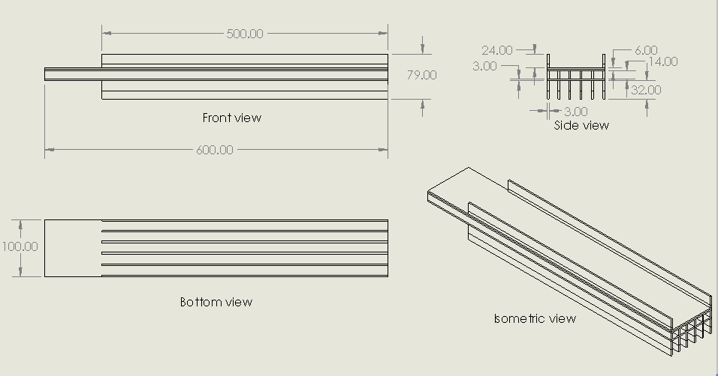
Design overview

To compensate for the constraints of this project and to make the best of what is available, the main problem being having only one fixed support. So, our main design philosophy is to maximize the Inertia of the design of the bridge and to evenly distribute the force throughout the design. The modified bridge design consists of a reinforced bridge deck, doubling its base thickness to increase its cross-sectional area, increasing its Inertia and thus, reducing its final deflection. However, this is not sufficient in terms of maximum deflection, so the use of I-beams is utilized to maximize the potential in reducing deflection by increasing its Inertia, six 600x14x3mm I beam and supported at the base by an additional beam. Furthermore, 6 additional T-beams [] (500x32x3mm) are designed to further increase its height, thus increasing its Inertia while saving material to meet the given amount. And the end result is a robust design of the bridge, designed to carry the given load of the PAScars, with its material cost being 2904cm2 (the original Fabrication Request was 2988cm2 but due to re-designs, some parts have to be modified to meet our requirements).

Bill of Materials
Part | Quantity | Area (cm2) each | Total area (cm2) | Description
Guard rail | 2 | 30 | 60 | Guard rails for the bridge deck
I beam (18mm) | 8 | 90 | 720 | I beam for support
I beam (14mm) | 6 | 84 | 504 | I beam for support
I beam (14mmx500) | 6 | 70 | 420 | I beam for support
Bridge Deck | 2 | 600 | 1200 | A replica of the bridge deck to strengthen the deck
 |  | Sum | 2904

Structure analysis
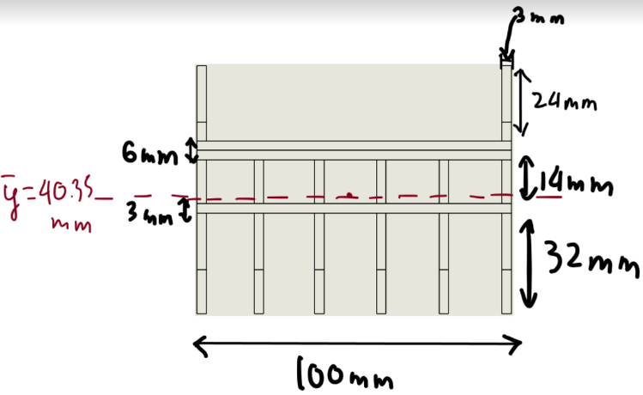
$$\overline{y}=\frac{2\left[\left(67\right)\left(3\right)\left(24\right)\right]+\left(52\right)\left(6\right)\left(100\right)+6\left[\left(42\right)\left(3\right)\left(14\right)\right]+\left(33.5\right)\left(3\right)\left(100\right)+6\left[\left(16\right)\left(32\right)\left(3\right)\right]}{\left(2\right)\left(3\right)\left(24\right)+6{\left(100\right)}^{+6}\left(3\right)\left(4\right)+3\left(100\right)+6\left(32\right)\left(3\right)}$$
$$=40.35mm$$
$I=2\left[\frac{1}{12}\left(3\right){\left(14\right)}^{3}+\left(3\right)\left(24\right){\left(26.65\right)}^{2}\right]+\left[\frac{1}{12}\left(100\right){\left(6\right)}^{3}+{\left(11.65\right)}^{2}\left(100\right)\left(6\right)\right]+6\left[\frac{1}{12}\left(3\right){\left(14\right)}^{3}+\left(3\right)\left(14\right){\left(1.65\right)}^{2}\right]+\left[\frac{1}{2}\left(100\right){\left(3\right)}^{3}+\left(100\right)\left(3\right){\left(6.85\right)}^{2}\right]$+$6\left[\frac{1}{12}\left(3\right){\left(32\right)}^{3}+\left(3\right)\left(32\right){\left(24.35\right)}^{2}\right]$
$=109184.04+83233.5+4802.07+14301.75+390675.36$
=$6.022⋅{10}^{-7}m^{4}$
Volume of the 500mm Acrylic along the bridge:
$$V=A×thickness=\left(3120×{10}^{2}\right)×3=921000{mm}^{3}=921{cm}^{3}$$

Design Load Cases
To consider for the ‘worst case scenarios’ in our design, we chose three load cases:
- Load case 1: The two Pascars’ combined load of 8kg acting on the free end of the bridge presented by four wheels of the cars along with the distributed load throughout the bridge which is caused by its self-weight.
- Load case 2: The two Pascars’ combined load of 8kg acting on the middle of the bridge presented by four wheels of the cars along with the distributed load throughout the bridge which is caused by its self-weight.
- Load case 3: The two Pascars’ combined load of 8kg acting on the position which is close to the fixed support of the bridge presented by four wheels of the cars along with the distributed load throughout the bridge which is caused by its self-weight.
For each load case, the forces of the four wheels of the two Pascars combination should be the same since the distance between two wheels of one car is uniform and each car only carries 4kg load and divides force equally. Thus, force of each wheel acting on the bridge should be:
$$P_{1}=P_{2}=P_{3}=P_{4}=\frac{m×g}{4}=\frac{8×9.8}{4}=19.6(N)$$
To determine the distributed load of the bridge’s self-weight, we firstly find the volume of the Acrylic along the bridge’s length of $500mm$, which is $921{cm}^{3}$, then calculate its total mass:
$$m=density×V=1.18×921=1086.78(g)=1.08678(kg)$$
Thus, the distributed load along $500mm$ bridge is:
$$W=\frac{mg}{L}=\frac{1.08678×9.8}{0.5}=21.3(N/m)$$
These load cases were selected to determine which cases cause the maximum bending stresses, maximum shear stress, maximum curvature and maximum deflection.

*Load case 1:

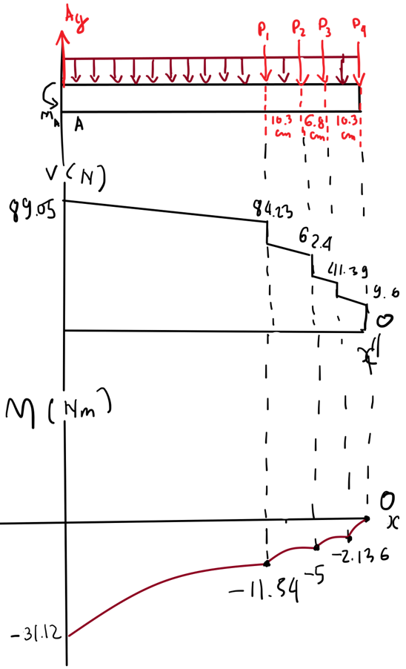
Maximum Stress Analysis
$$∑F_{y}=A_{y}-21.3⋅0.5-\left(19.6⋅4\right)=0$$
$$→A_{y}=89.05(N) \\ ΣM_{A}=-\left(21.3⋅0.25⋅0.5\right)-\left(19.6⋅0.226\right)-\left(19.6⋅0.329\right)-\left(19.6⋅0.397\right)-\left(14.6⋅0.5\right)+M_{A}=0$$
$$→M_{A}=31.1217(Nm)$$

According to the shear-moment diagram, we could figure out the maximum shear force and maximum bending moment acting on the bridge in this case are $89.05N$ and $31.1217Nm$ respectively
Since the moment makes the bridge concave down, the maximum bending stresses caused by maximum bending moment are tensile at the top and compressive at the bottom of the bridge.
$$σ_{tensile max}=\frac{M_{max}×c_{top}}{I}=\frac{31.1217×0.03865}{6.022×{10}^{-7}}=2×{10}^{6}Pa=2MPa$$
$$σ_{compressive max}=\frac{M_{max}×c_{bottom}}{I}=\frac{31.1217×0.04035}{6.022×{10}^{-7}}=2.1×{10}^{6}Pa=2.1MPa$$
The maximum longitudinal stress caused by maximum shear stress is at the neutral axis:
$$τ_{max}=\frac{V_{max}×Q}{I×t}=\frac{89.05×(1.12234×{10}^{-7})}{0.003×(6.022×{10}^{-7})}=5532.18Pa$$

Deflection Analysis
The maximum curvature in the bridge is:
$$\frac{1}{ρ}=\frac{M_{max}}{EI}=\frac{31.1217}{(1800×{10}^{6})×(6.022×{10}^{-7})}=0.0287m^{-1}$$
As the bridge is the type of cantilever beam, its maximum deflection should be at the free end. To determine this parameter in each load case, we needed to find the equation of the deflection at the free end when a concentrated load acting on as well as the one when the distributed load acting along the bridge, then sum all of the calculated deflection at the free end caused by each load to get the total maximum deflection.
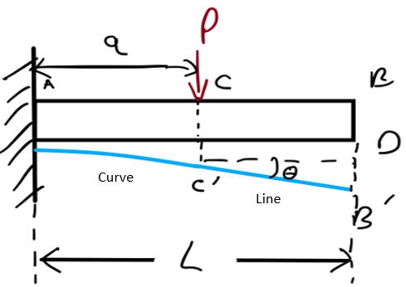
- Concentrated load:

The equation to determine the slope and deflection from the fixed support (Point A) to the concentrated load (Point C) which creates the curve under this distance is
$$θ_{C}=\frac{-Pa^{2}}{2EI} (Appendix C) \\ yc=\frac{-Pa^{3}}{3EI}=CC^{'} (Appendix C)$$
We have: $y_{B}=BB^{'}=BD+DB^{'}=CC^{'}+DB^{'}=\frac{-Pa^{3}}{3EI}+DB^{'}$(1)
Slope of elastic curve at C’ = Slope of line C’B’ (constant)
$$→\frac{-Pa^{2}}{2EI}=y_{C'B'}^{'}$$
We have: $\tan{θ}=\frac{DB^{'}}{\left(L-A\right)}→ DB^{'}=\left(L-A\right)\tan{θ}$
Since $θ$is very small $→tanθ=0$
$DB^{'}=\left(L-a\right)θ=-\left(L-a\right)\frac{Pa}{2EI}$ (2)
From (1) and (2):
$$→y_{B}= \frac{-P×a^{3}}{3EI}-\frac{\left(L-a\right)Pa^{2}}{2EI}$$
- Distributed load:
$$y_{B}=\frac{-WL^{4}}{8EI} (Appendix C)$$
Substitute the values of the parameters which were determined before into the equations and calculate the result of the deflection caused by each load, we got:
*Concentrated load cases:$y_{B}= \frac{-P×a^{3}}{3EI}-\frac{\left(L-a\right)Pa^{2}}{2EI}; P=19.6N; E=1800MPa; I=6.022×{10}^{-7}m^{4};L=0.5m$
$Case P_{1} (a=0.226m): y_{B_P1}=-1.96×{10}^{-4}m$; $Case P_{2} \left(a=0.329m\right): y_{B_{P2}}=-3.82×{10}^{-4}m;$
$Case P_{3} (a=0.397m): y_{B_P3}=-5.24×{10}^{-4}m$; $Case P_{4} \left(a=0.5m\right): y_{B_P4}=-7.53×{10}^{-4}m$
*Distributed load case:$y_{B}=\frac{-WL^{4}}{8EI};W=21.3N/m$
$$y_{B_W}=-1.54×{10}^{-4}m$$
Thus, the total maximum deflection of the bridge at the free end is:
$$y_{Bmax}=-1.96×{10}^{-4}-3.82×{10}^{-4}-5.24×{10}^{-4}-7.53×{10}^{-4}-1.54×{10}^{-4}=-20.09×{10}^{-4}m$$
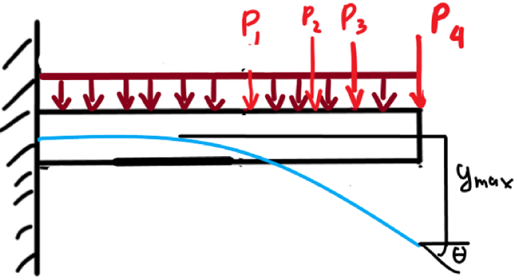
*Elastic curve:

- The elastic curve under this load case bends downward mostly in the free end range affected by the four concentrated loads $P_{1},P_{ 2},P_{3},P_{ 4}$

*Load case 2:

Maximum Stress Analysis
$$ΣF_{y}=A_{y}-21.3⋅0.5-\left(19.6⋅4\right)=0$$
$$ΣM_{A}=0=-\left(21.3⋅0.5⋅0.25\right)-\left(19.6⋅0.11\right)-\left(19.6⋅0.216\right)-\left(19.6⋅0.28\right)-\left(19.6⋅0.38\right)+M_{A}$$
$$→M_{A}=22.2625Nm$$
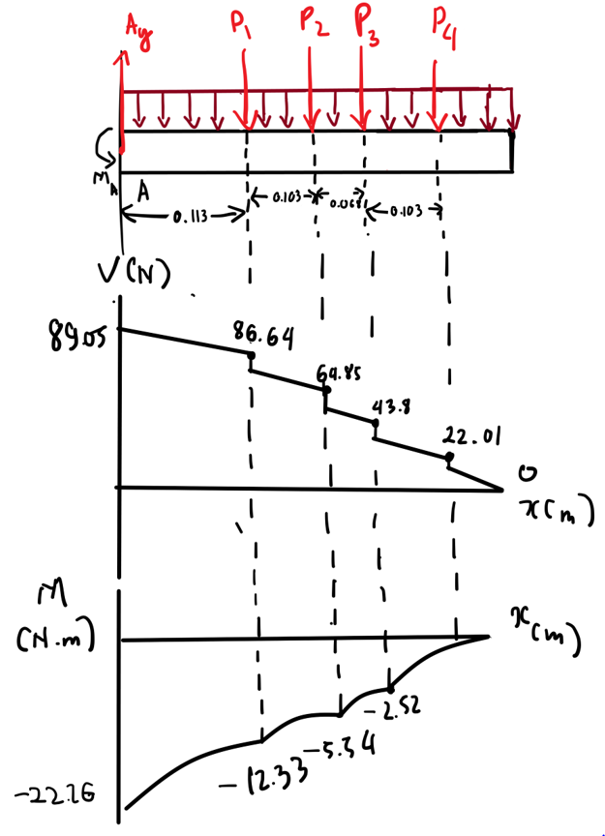

According to the shear-moment diagram, we could figure out the maximum shear force and maximum bending moment acting on the bridge in this case are $89.05N$ and $22.2625Nm$ respectively
Since the moment makes the bridge concave down, the maximum bending stresses caused by maximum bending moment are tensile at the top and compressive at the bottom of the bridge.
$$σ_{tensile max}=\frac{M_{max}×c_{top}}{I}=\frac{22.2625×0.03865}{6.022×{10}^{-7}}=1.43×{10}^{6}Pa=1.43MPa$$
$$σ_{compressive max}=\frac{M_{max}×c_{bottom}}{I}=\frac{22.2625×0.04035}{6.022×{10}^{-7}}=1.5×{10}^{6}Pa=1.5MPa$$
The maximum longitudinal stress caused by maximum shear stress is at the neutral axis:
$$τ_{max}=\frac{V_{max}×Q}{I×t}=\frac{89.05×(1.12234×{10}^{-7})}{0.003×(6.022×{10}^{-7})}=5532.18Pa$$

Deflection Analysis
The maximum curvature in the bridge is:
$$\frac{1}{ρ}=\frac{M_{max}}{EI}=\frac{22.2625}{(1800×{10}^{6})×(6.022×{10}^{-7})}=0.02m^{-1}$$
The maximum deflection of the bridge in this load case is determined by using the same method and equations which were proved and applied in the load case 1.
*Concentrated load cases:$y_{B}= \frac{-P×a^{3}}{3EI}-\frac{\left(L-a\right)Pa^{2}}{2EI}; P=19.6N; E=1800MPa; I=6.022×{10}^{-7}m^{4};L=0.5m$
$$Case P_{1} (a=0.113m): y_{B_{P1}}=-5.34×{10}^{-5}m$$ | $$Case P_{3} \left(a=0.284m\right): y_{B_{P3}}=-2.96×{10}^{-4}m$$
$$Case P_{2} \left(a=0.216m\right): y_{B_{P2}}=-1.8×{10}^{-4}m$$ | $$Case P_{4} \left(a=0.387m\right): y_{B_P4}=-5.02×{10}^{-4}m$$

*Distributed load case:$y_{B}=\frac{-WL^{4}}{8EI};W=21.3N/m$
$$y_{B_W}=-1.54×{10}^{-4}m$$
Thus, the total maximum deflection of the bridge at the free end is:
$$y_{Bmax}=-5.34×{10}^{-5}-1.8×{10}^{-4}-2.96×{10}^{-4}-5.02×{10}^{-4}-1.54×{10}^{-4}=-11.854×{10}^{-4}m$$
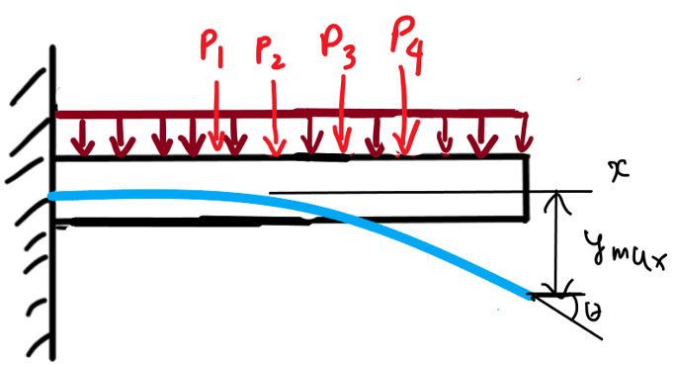
*Elastic curve:

- The elastic curve under this load case bends downward mostly in the middle range affected by the four concentrated loads $P_{1},P_{ 2},P_{3},P_{ 4}$

*Load case 3:

Maximum Stress Analysis
$$ΣF_{y}=A_{y}-21.3⋅0.5-19.6⋅4=0 \\ →A_{y}=89.05N \\ ΣM_{A}=0=M_{A}-19.6⋅\left(0.103\right)-19.6\left(0.171\right)-19.6\left(0.274\right)-\left(21.3⋅0.5⋅0.25\right) \\ →M_{A}=13.4033N.m$$
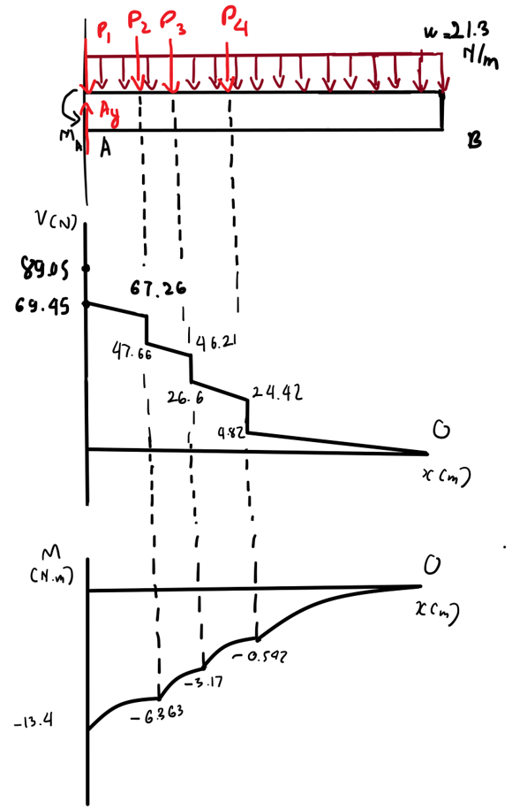

According to the shear-moment diagram, we could figure out the maximum shear force and maximum bending moment acting on the bridge in this case are $89.05N$ and $13.4033Nm$ respectively.
Since the moment makes the bridge concave down, the maximum bending stresses caused by maximum bending moment are tensile at the top and compressive at the bottom of the bridge.
$$σ_{tensile max}=\frac{M_{max}×c_{top}}{I}=\frac{13.4033×0.03865}{6.022×{10}^{-7}}=0.86×{10}^{6}Pa=0.86MPa$$
$$σ_{compressive max}=\frac{M_{max}×c_{bottom}}{I}=\frac{13.4033×0.04035}{6.022×{10}^{-7}}=0.9×{10}^{6}Pa=0.9MPa$$
The maximum longitudinal stress caused by maximum shear stress is at the neutral axis:
$$τ_{max}=\frac{V_{max}×Q}{I×t}=\frac{89.05×(1.12234×{10}^{-7})}{0.003×(6.022×{10}^{-7})}=5532.18Pa$$

Deflection Analysis
The maximum curvature in the bridge is:
$$\frac{1}{ρ}=\frac{M_{max}}{EI}=\frac{13.4033}{(1800×{10}^{6})×(6.022×{10}^{-7})}=0.01m^{-1}$$
The maximum deflection of the bridge in this load case is determined by using the same method and equations which were proved and applied in the load case 1.
*Concentrated load cases:$y_{B}= \frac{-P×a^{3}}{3EI}-\frac{\left(L-a\right)Pa^{2}}{2EI}; P=19.6N; E=1800MPa; I=6.022×{10}^{-7}m^{4};L=0.5m$
$Case P_{1} (a=0m): y_{B_{P1}}=0m$; $Case P_{2} \left(a=0.103m\right): y_{B_{P2}}=-4.47×{10}^{-5}m$
$Case P_{3} \left(a=0.171m\right): y_{B_{P3}}=-1.171×{10}^{-4}m$; $Case P_{4} \left(a=0.274m\right): y_{B_P4}=-2.77×{10}^{-4}m$
*Distributed load case:$y_{B}=\frac{-WL^{4}}{8EI};W=21.3N/m$
$$y_{B_W}=-1.54×{10}^{-4}m$$
Thus, the total maximum deflection of the bridge at the free end is:
$$y_{Bmax}=0-4.47×{10}^{-5}-1.171×{10}^{-4}-2.77×{10}^{-4}-1.54×{10}^{-4}=-5.928×{10}^{-4}m$$
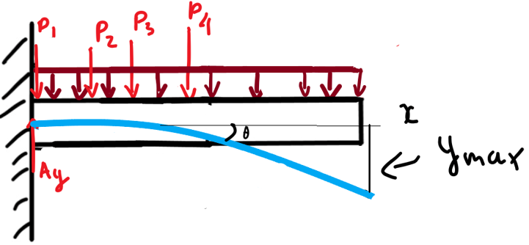
*Elastic curve:

- The elastic curve under this load case bends downward mostly in the fixed support range affected by the four concentrated loads $P_{1},P_{ 2},P_{3},P_{ 4}$.
Overall, based on the analysis of all load cases, we can observe that the load case 1 has the maximum bending stresses$(σ_{tensile max}=2MPa$ ;$σ_{compressive max}=2.1MPa)$ as well as the maximum curvature ($0.0287m^{-1})$. This is gained by the relation that the moment is proportional to these parameters through their formula. So the bending moment in case 1 is maximum, which leads to the maximum values for these parameters. The longitudinal shear stress remains the same in all cases$(5532.18Pa)$ since the maximum shear force does not change. Moreover, the maximum deflection in case 1 is also the highest $ymax= -20.09×{10}^{-4}m$. Therefore, it can be concluded that case 1 is the ‘worst-case scenario’.
Let’s consider the safety factor in worst case, we could found the allowable shear stress:
$$S.F=1.5→\frac{σ_{y}}{σ_{allow}}=1.5→σ_{tensile allow}=\frac{48}{1.5}=32MPa$$
We can see that the calculated maximum tensile stress is less than the allowable tensile stress $(2MPa<32MPa)$. In addition, the maximum deflection is only $20.04×{10}^{-4}m=2.004mm$, it is less than the limited deflection required which is 5mm. Hence, our bridge is perfectly meeting the project’s requirements.

Conclusion
Upon finalizing our design and calculations, the prototype ends up with a maximum deflection of $-20.09×{10}^{-4}m$ in its worst-case scenario; It can be predicted with high accuracy that this bridge’s loading capability is sufficient for the 2 PASCars to cross the chasm. Due to the implementation of the I-beams and T-beams, we are confident that this design can be sustain its worst-case scenario, both loading-wise and with its lowest Young’s Modulus value.

[1] Nguyen Chi, T., 2022. [online] Rmit.instructure.com. Available at: <https://rmit.instructure.com/courses/100635/assignments/663780> [Accessed 17 May 2022].
[2] Hibbeler.R.C, Statics & Mechanics Materials SI, 15th ed. Melbourne: P. Ed Custom Books, 2019, pp. 287-290.
[3] R. Hibbeler, Mechanics of materials, 10th ed. London, UK: Pearson, 2018, pp. 813-814.

