15 July 2024

**Control No. 2024-**

**Date: ___________________**

**Released: _______________**

8 Muharram 1446

|  |  |
| --- | --- |
| FOR : | **JONATHAN M. MANTIKAYAN, PhD.IT**  Executive Director II  Bangsamoro Information and Communications Technology Office  **THRU: DATU RAFFY RALPH S. SINSUAT, MSc.IT**  Information Technology Officer I  Information Systems Development and Management Section  Bangsamoro Information and Communications Technology Office |

Dear Sir;

*Assalamu Alaikum Warahmatullahi Wabarakatuhu*

I hope this message finds you well. We are writing to formally request approval to acquire a Canva subscription for our office use for the following employees namely; Sittie Yana Mardeyah I. Sanday – Communication Officer, and Korina L. Kabagani – Administrative Aide V of Bangsamoro Information and Communications Technology Office.

Canva is an online platform that provides a comprehensive suite of design tools, essential for creating high-quality graphics and visual content, which would greatly benefit our team in accomplishing tasks.

We kindly request your approval to proceed with the subscription, and we are available to discuss this further if needed. Thank you for considering this request. We are confident that access to Canva will significantly contribute to our team's success and personal progress.

Looking forward to your positive response.

Sincerely,

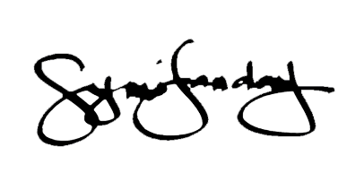

Sittie Yana Mardeyah I. Sanday

Communication Officer