SECTION A

1.

a) The Warner Bros website’s intention is to showcase premiering movies and TV shows to the public, it continues to showcase games and apps that are created or that resemble the movies and TV shows in the Warner Bros website, the website also shows the brands that are mostly common in the website, it also shows collections of movies and the TV shows which are the Hottest picks, actions and adventure picks etc. The Warner Bros website coneys press releases about the movie and TV show production and it also revels the experience and shops that are run by the company.

b) The target audience is youth from the age of 15-35

c) The type of website that I will be designing for the users is a Video website that will be showcasing new movies and TV shows.

2. **Information Design and Taxonomy**

Warner Bros

Looney Tunes shop

DC shop

WB shop

HOME PAGE

Feedback page

Footer

Movies

TV Shows

Collections page

Games & Apps

Shop

Recent Updates

New Series

Most popular today

Video games

Comedy

Facebook

Romance

Updated Series

Twitter

Recent Updates

Pinterest

Most popular

Mobile games & apps

Adventure

Popular Series

DC Movies

Coming soon

Instagram

LinkedIn

YouTube

3. **Page Template Design**

On this page, which is the home page the user will be able to see movies that are most popular on that day it also shows the movies and TV shows that have been recently updated in the website and the page shows movies and TV shows that are been released in the near future.

The movies page showcases movies that are popular on that day, it also shows movies that that have been recently released and lastly it shows movies that were published by DC.

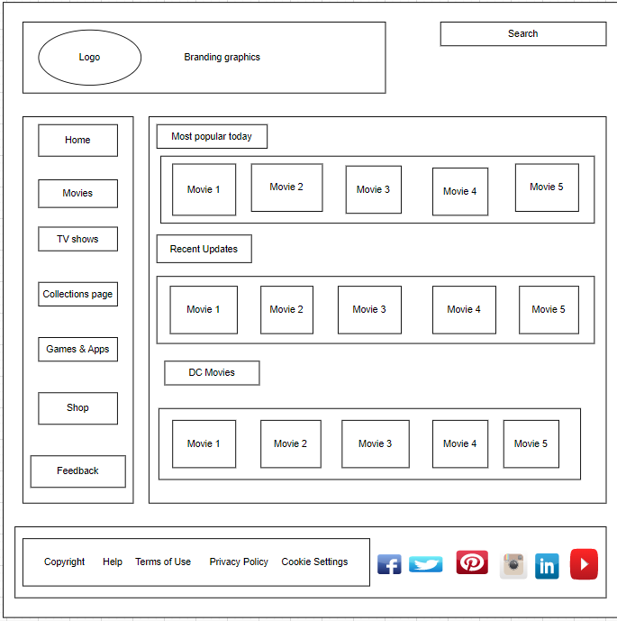

The TV show page shows series that are new and have just been recently released, it also shows series that have been updated and it also shows popular series that are mostly watched during that specific period.

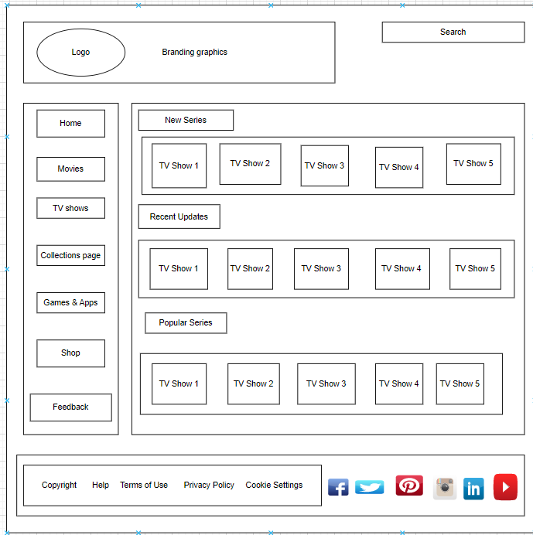

The collections page contains multiple genres for the movies and TV shows which are comedy, romance, action, animation, horror, thriller, adventure and sci-fi. Movies and TV shows that are of the same genre are grouped together and named after that specific genre.

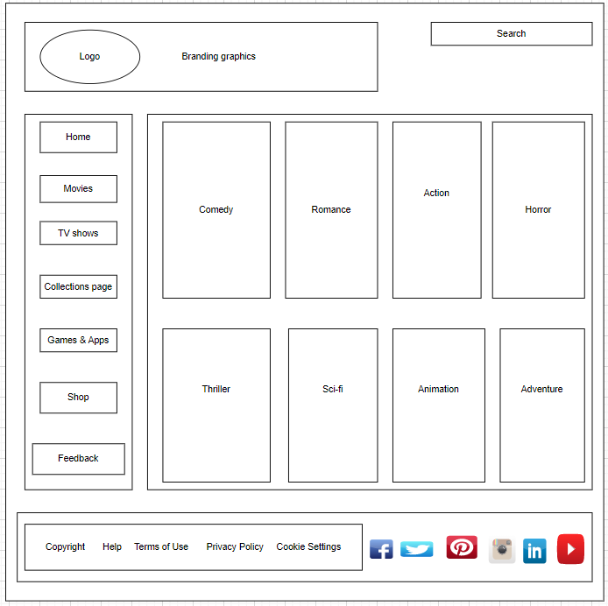

The games & apps page showcases video games that were made by the Warner Bros company and it also shows the mobile games & apps that are accessed on a mobile device only.

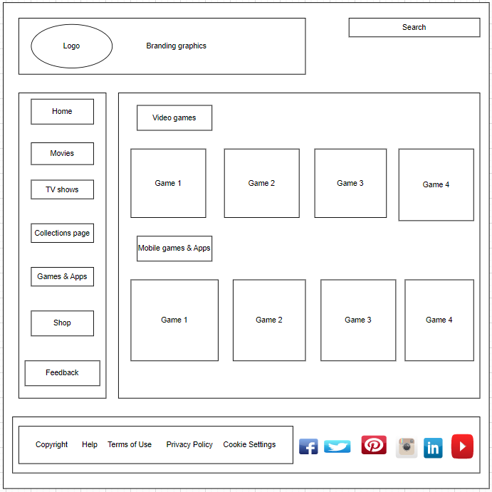

The shop page consists of different shops which are the WB shop, DC shop and Looney Tunes shop all this shops are run by the warner bros company and they sell different items for every shop.

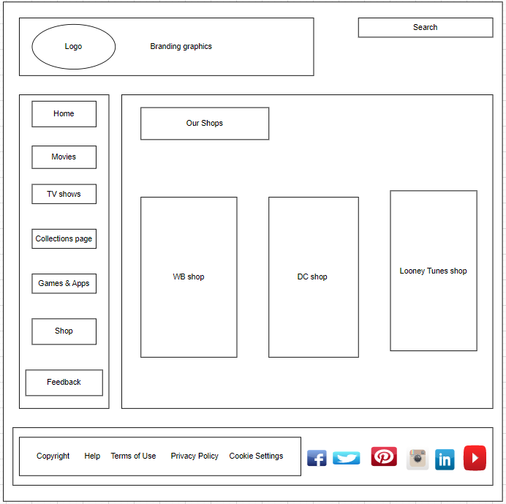

The feedback page is where the user will fill in questions that the developer may have regarding the website.

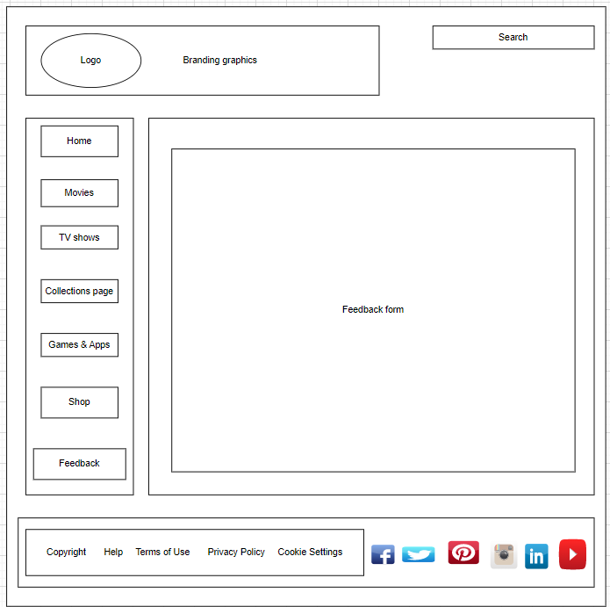

4. Technical Brief

I used the following software application for my website planning.

Lucid chat- it is a software where wireframes can be created it provides a variety of tools and shapes.

Visual studio code- it is a software used to create code it even helps one to identify errors and it brings websites into existence.

5. Quality Assurance

I checked my website with Microsoft edge

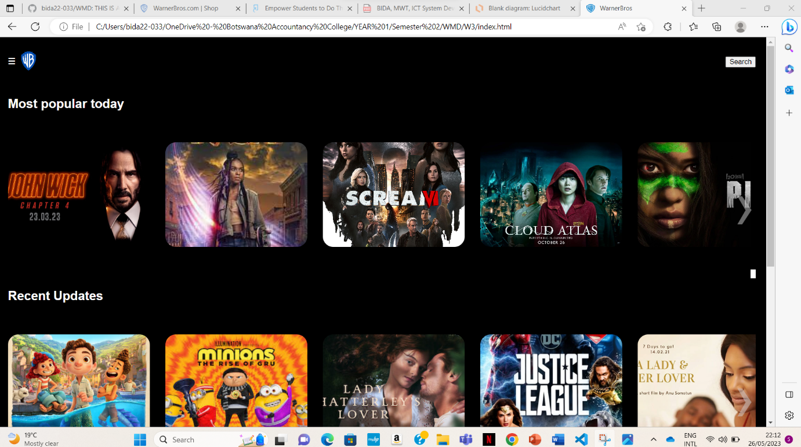

I checked it with Google chrome

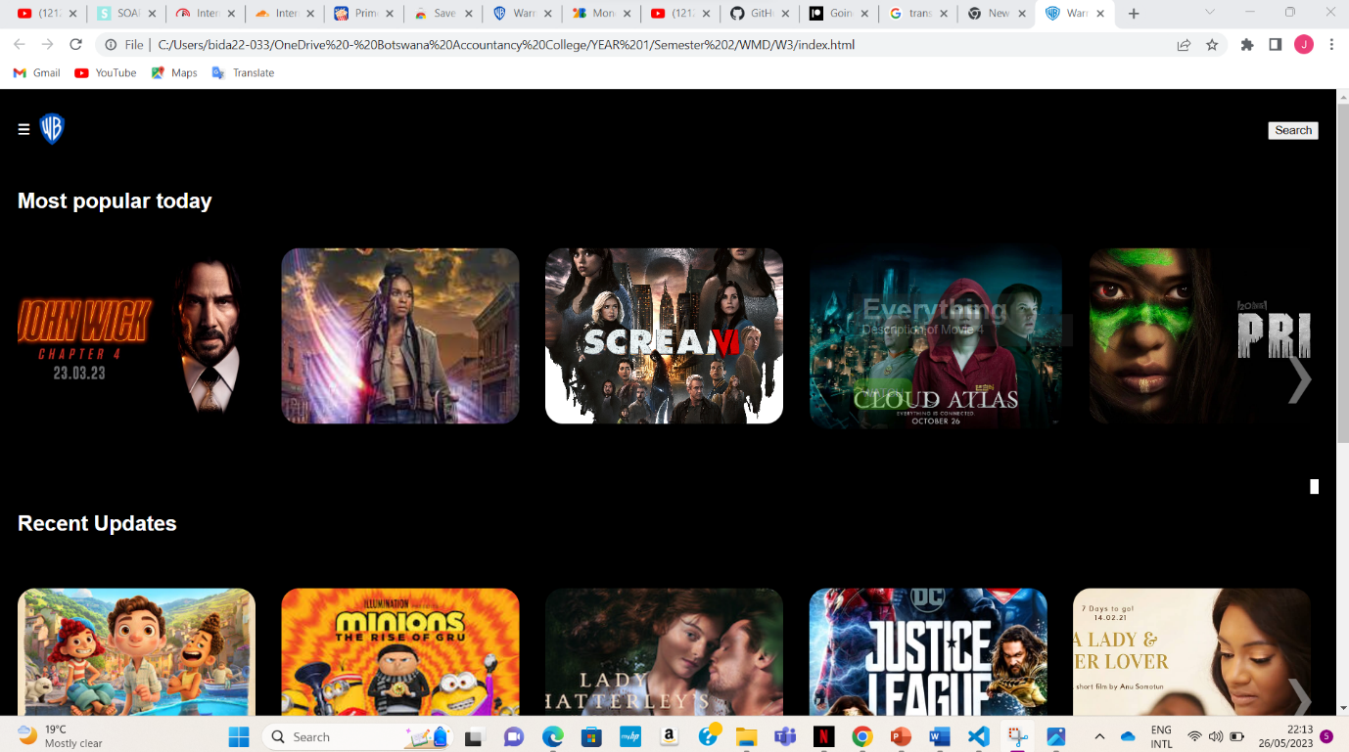

I also tested it on Firefox

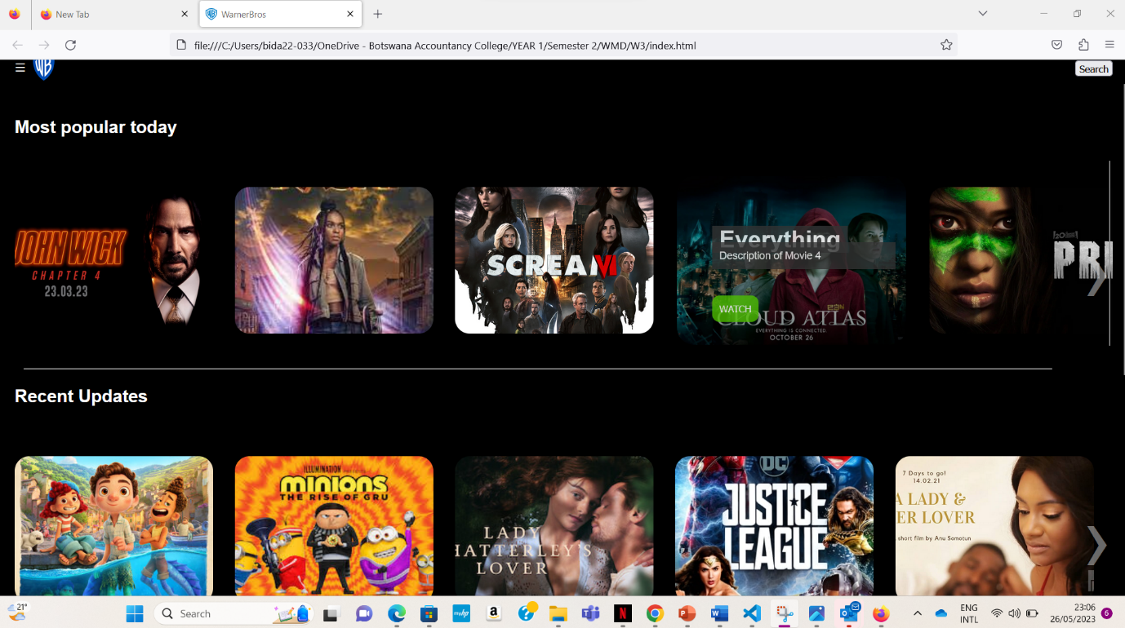

6. Below is evidence of publishing my website on GitHub

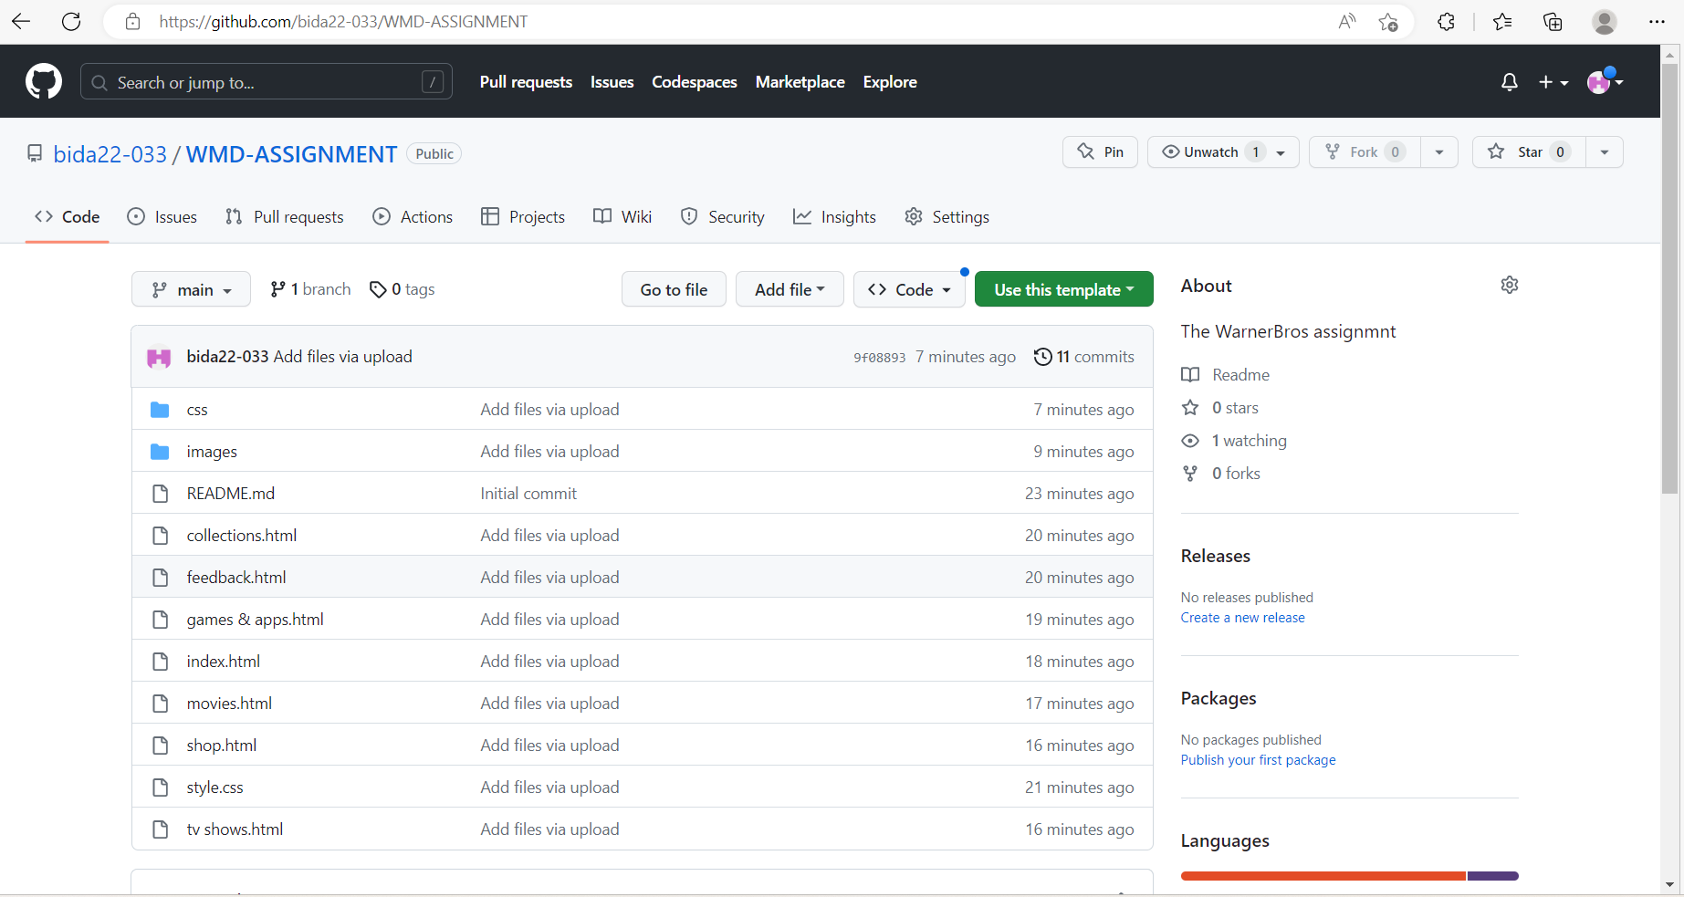

7. Future Developments

- Move the navigation to where the customer can easily access and navigate