**ASSIGNMENT SUBMISSION COVER SHEET**

Bida22-042

**Student Id:**

Amantle Magotho

**Student names:**

**Student email**:

Bida22-042@thuto.bac.ac.bw

**Cohort**:

Bida1-2

**Assignment title:**

Web & Multimedia Development

**Date of submission:**

28 May 2023

**Programme of study:**

BIDA

**Year of study:**

2023

**Intellectual property statement**

By checking the box below, I certify that this assignment is my own work and is free from plagiarism. I understand that the assignment may be checked for plagiarism by electronic or other means and may be transferred and stored in a database for the purposes of data-matching to help detect plagiarism. The assignment has not previously been submitted for assessment in any other unit or to any other institution.

**I have read and understood the Botswana Accountancy College plagiarism guidelines policy.**

☐ Agree **Signature**…………………………………….



**Date**………………………………………….

**Table of Contents**

**ABOUT WARNER BROS** 3

**WEB SITE SPECIFICATIONS** 3

**INFORMATION AND TAXONOMY DESIGN** 4

**PAGE TEMPLATE DESIGN** 4

**TECHNICAL BRIEF** 5

**QUALITY ASSURANCE** 5

**PUBLISHING AND PROMOTION** 5

**FUTURE DEVELOPMENTS / RECOMMENDATIONS** 5

**Warner Bros. Inc**

# **ABOUT WARNER BROS**

Warner Bros is a Warner Media entertainment company leading globally in the creation, production, distribution, licensing, and marketing of all forms of entertainment.

The company’s library consists of one of more than 114000 hours of programming. The subsidiary companies that are part of the Warner Bros. Entertainment include the following:

* Warner Bros. Pictures Group which produces and distributes a wide range of films each year. This group produced the well-known DC Superheroes which is home to the world’s greatest superheroes including Batman, Wonder woman, Green Lantern and more.
* Warner Bros. Home Entertainment brings together the Warner Bros. Interactive Entertainment businesses. This focuses on videogames and home video.
* Warner Bros. Animation creates the series of DC original animated movies for DVD. DC is an English-Language publisher of comics and graphic novels.

The Warner Bros. Television Group oversees all the Warner Bros.’ television businesses. (Anon., n.d.)

The Warner Brothers began producing their own films in 1913. The Warner Brothers Pictures Inc was however established in 1923. (The Editors of Encyclopaedia Britannica, 2014)

# **WEB SITE SPECIFICATIONS**

The objective of this website is to serve as a platform for users to watch movies, see which video games they can play, view apps that can be downloaded, see more information about Warner bros and finally, send a newsletter about what they may want to be featured on the website. The main goal is to give viewers more in-depth information about Warner Bros movies and TV shows. The site allows the user to watch trailers of upcoming movies and see the release date.

Due to technology advancing by the day, Warner Bros needs to stay ahead of the entertainment industry by adding new features to make the website more perceivable, operable, understandable, and robust for the user. This is the reason why I am re-designing the website.

This website targets the individuals who may be interested in different movie genres ranging from action, comedy, and horror. It also caters for children who may be interested in watching animated movies and TV shows. The demographics of the target audience include children and adults between the ages of 10 to 45, of all religions and located anywhere in the world. In short, there’s something for everyone!

Accessibility features:

* Enabling dark/light mode
* Choosing language preferred, default is English.

# **INFORMATION AND TAXONOMY DESIGN**

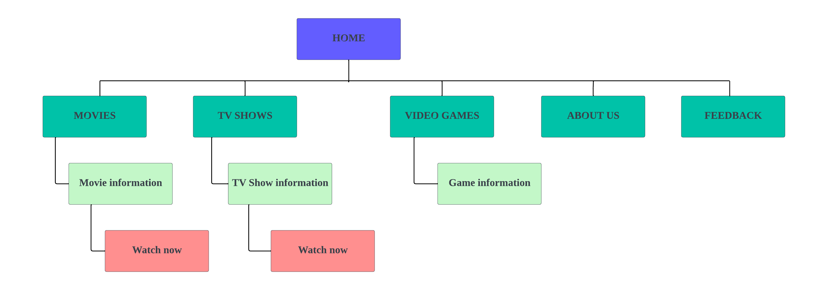

# **PAGE TEMPLATE DESIGN**



# **TECHNICAL BRIEF**

I will Lucid Chart to create the site map of the webpage. I will Microsoft Word to create the page template design and for the HTML and CSS code, I will Visual studio code. I will get icons to represent buttons from the Bootstrap website.

# **QUALITY ASSURANCE**

(Screenshots of where the website has been tested)

**Testing on browsers:**

1. **Google Chrome:**

1. Microsoft edge:

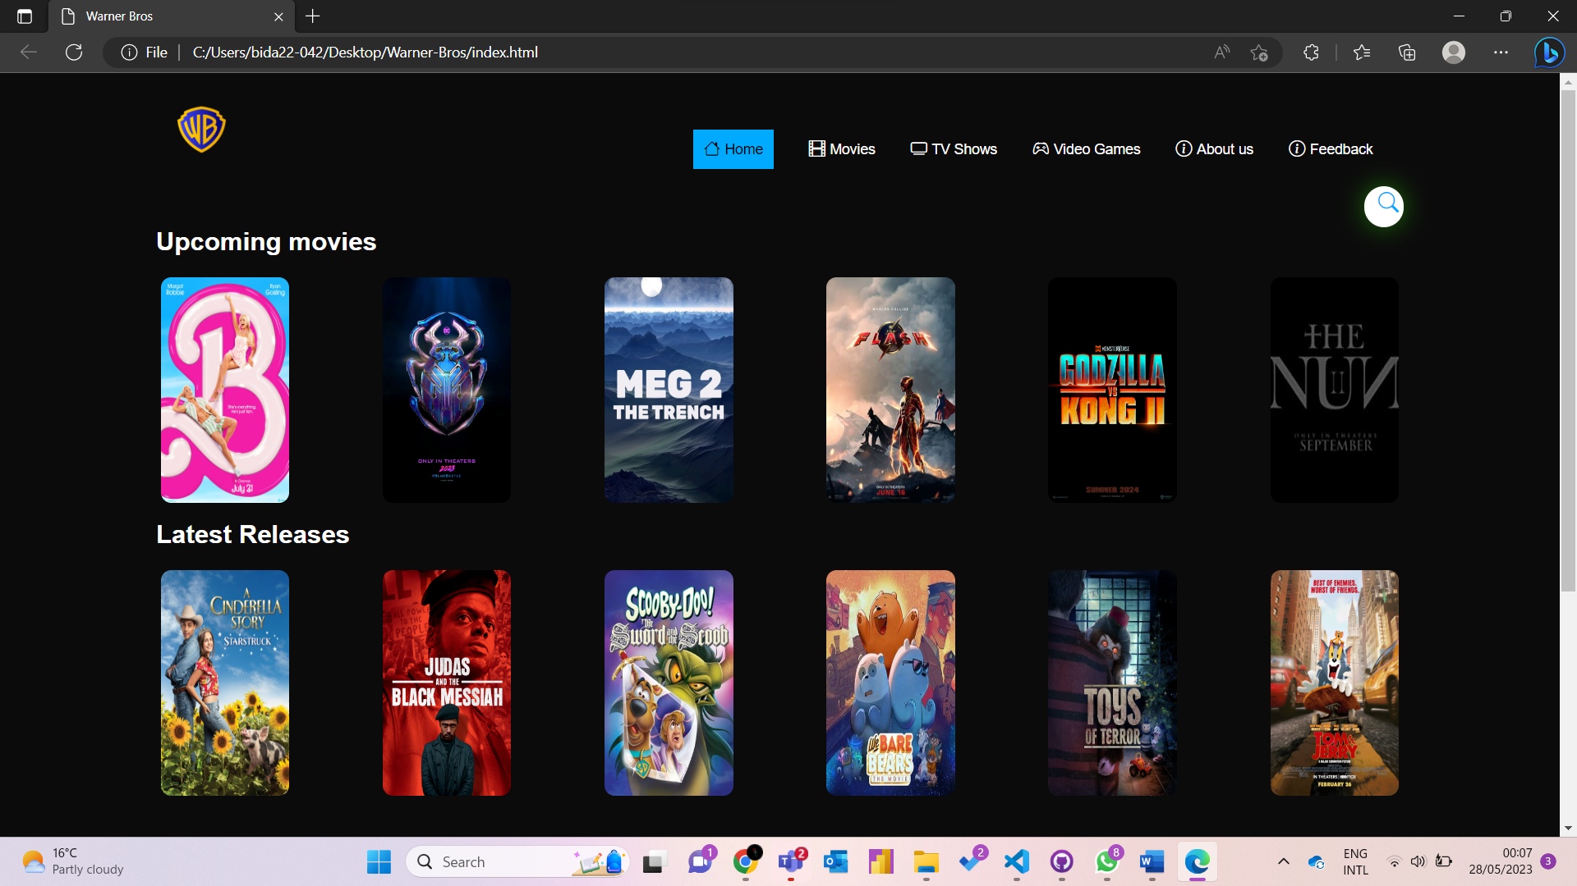

**Testing on different devices:**

iPhone XR on portrait mode: width is equal to 414 and height is equal to 896.

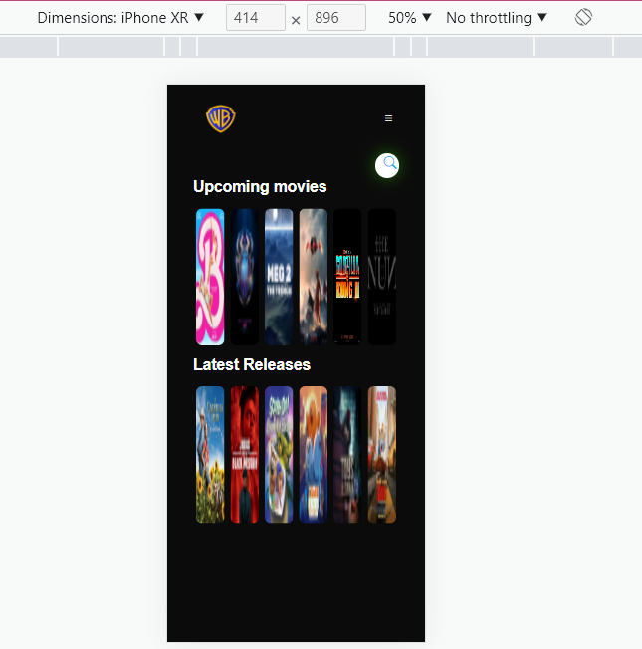

iPad: width is equal to 768 and height is equal to 1024.

Galaxy tab S4 on portrait mode:

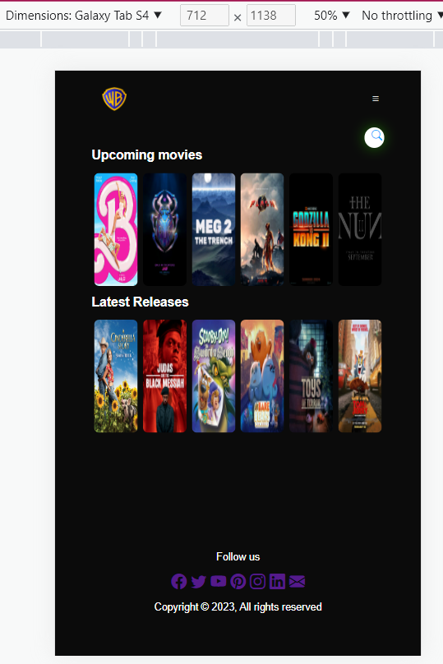

# **PUBLISHING AND PROMOTION**

Using GitHub desktop, I created a new repository and named it Warner Bros. I also added a README file. I proceeded to save the file on my desktop, then copied the files I used for the website and pasted them in the new repository folder that contained only two files. Pushed the desktop repository onto GitHub online then I was able to access the website.

# **Website link:**

https://bida22-042.github.io/Warner-Bros/

# **FUTURE DEVELOPMENTS / RECOMMENDATIONS**

Create a more personalized website that will allow users to create accounts. The user would have to log in to access the portal. This would allow for users to be able to view the movies/series that they have previously watched or if they had not watched till the end, continue from where they left off.

I would also like to add a sticky menu which would enable users to see the navigation bar even when they scroll down on the page. Additionally, add more accessibility features such as enabling dark mode, choosing the language and more.