How to build Splotch in Visual Studio

The code of Splotch is of standard C++ so in principle it should be no problem to be compiled in Visual Studio, only the custom of Unix-based development not compatible to Visual Studio's project managing fashion. For example, one problem is the different building paths (order) of files, which may cause more than one copy of the same component in VS, if not handled.

Follow the steps below to build Splotch in Visual Studio,

1. Check out the code from svn.
2. Create a Windows Console Application project in Visual Studio, better be in the root folder of the codes.
3. Add a preprocessor 'VS', meaning 'Visual Studio' to the project (Project property-> C/C++
->Preprocessor) .
4. Add all the .cc, .h files into this project manually (Porject->Add->Existing items).
5. Exclude certain files, including:
-cuda/splotch.cu (it will be introduced in another section of how to compile CUDA component)
-cuda/splotch_kernel.cu
-cuda/CuPolicy.cpp, CuPolicy.h
-reader/*.*
-writer/*.*
-fullsplotch.cc
6. Add the root directory into the project's Additional Include Directories.

Instead of fullsplotch.cc in Linux the beginning point of compiling will be splotch.cc where main() is.

Build the project as normal and the binaries will be generated.

For me I prefer to build folders in the Solution Explorer to manage the files as it is on hard disk, as shown below,
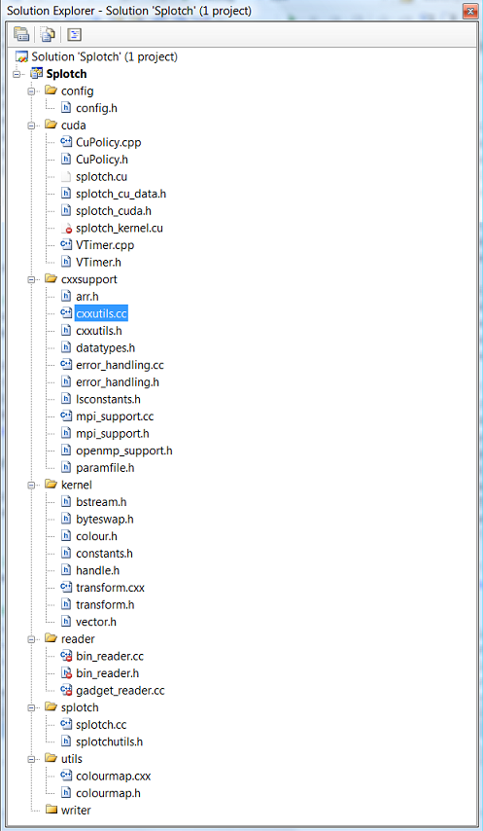

How to build CUDA component of Splotch in Visual Studio

First you need to go to Nvidia's site (www.nvidia.com) to download CUDA components, including
1. CUDA driver
2. CUDA sdk
then install them on your system.

Open the Programming Guide in Appendix A you can find a table of CUDA-supported graphics cards. Check your hardware to make sure.

Make sure you have Visual Studio 2005 or higher installed.

CUDA codes are actually C codes with very little extension (in the latest version it will support C++). They are subject to the compiler nvcc which will handle device (GPU) code by itself and call the system's compiler, in our case Visual C++ to handle host (CPU) code. Visual Studio provides a functionality called Custom Build Rule which allows users to wrap all the details in a xml file and left just one button for compiling CUDA files, which are usually suffixed with .cu.

Follow the steps below to build CUDA enhanced Splotch,
1. Suppose you have done building Splotch in Visual Studio without CUDA components, now include the files in 'cuda' folder, and exclude from building the file 'splotch_kernel.cu' (File property ->General ->Excluded From Build). This file is included by splotch.cu and will be compiled there.
2. Add a preprocessor 'CUDA' to switch on CUDA codes (Project property-> C/C++
->Preprocessor).
3. Add a Custom build rule to the project.
Porject property -> Custom Build Rules ->New Rule File
then choose 'Cuda-1.ruls' in folder 'cuda'. A new rule will be created naming 'CUDA Build Rule v2.1.1'.
4. Apply the rule to splotch.cu
File property -> General -> Tool ->Custom Build Rule
5. Add include directories for splotch.cu
(File property -> CUDA Build Rule v2.2.1 -> General ->Additional Include Directories)
Add the following:
$(CUDA_INC_PATH);
cuda sdk installation/common/inc;
./cuda
6. Add libs to the project
(Project property ->Configuration Properties ->Linker -> Input-> Additional Dependencies
Add the following:
cudart.lib
cutil64D.lib(or cutil32D.lib depending on your system)
cuda.lib
7. Now compile splotch.cu to see if things work ok.
8. If splotch.cu is compiled then build the whole porject which will link CUDA component to host code.

