1.

(i)

(1, -1, 2, 1) + (1, 0, -2, 1) -> (2, -1, 0, 1) -> (2, -1, 0)

(ii)

(iii)

(iv)

Conversion to homogeneous coordinates

X -> [1, -1, 2, 1] = Xh

H2 \* (H1 \* Xh)

H1 \* Xh = Xh1

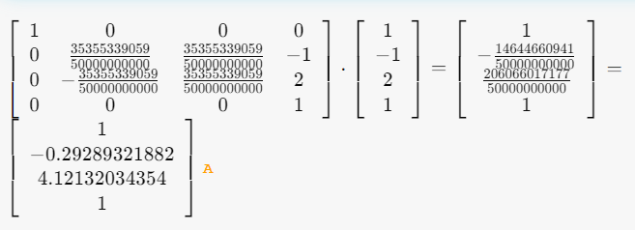

H2 \* Xh1 = Xh2

