 | android-rcs-ims-stack
 | RCS / IMS stack for Android platform

Configuration guide
Edition 1.0

Author:
Jean-Marc AUFFRET
jeanmarc.auffret@orange-ftgroup.com

Installation

Use the following command to install the RCS/IMS stack:

adb -d install "RCS core.apk"

Startup

The RCS/IMS stack is started at device boot or by using the “Settings” application:

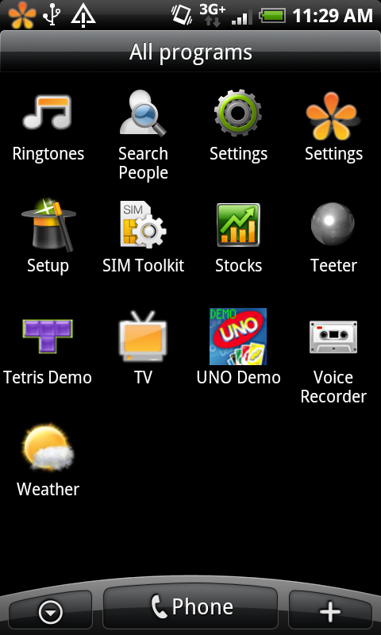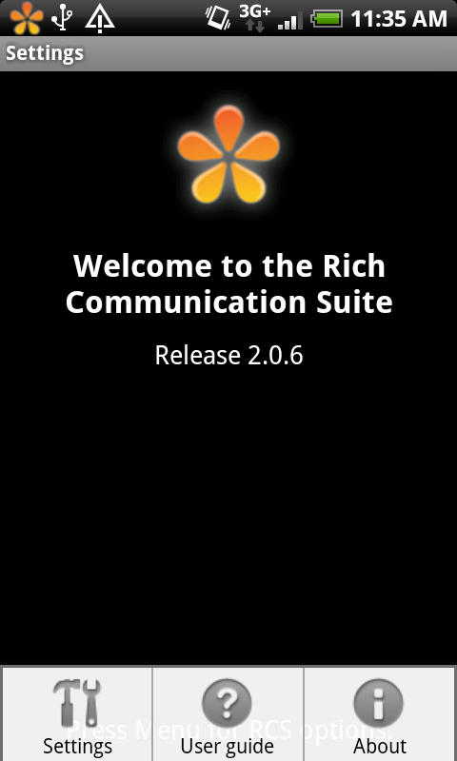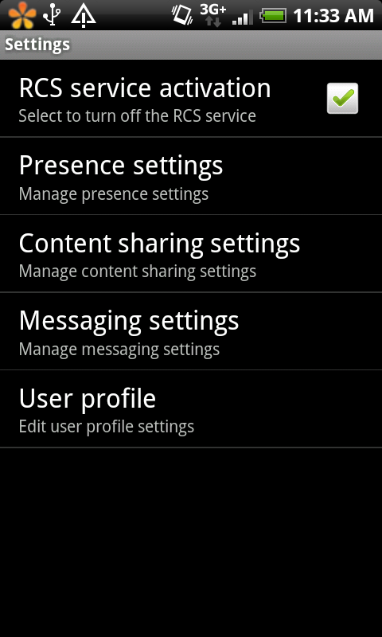
Start
stop

When the stack is started a dedicated notification is added in the top notification bar of the device:
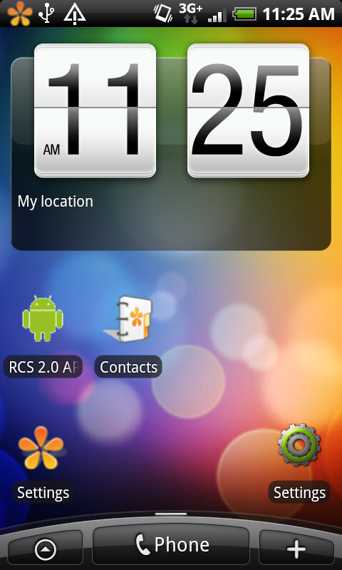
RCS notif

When the icon is grayed , it means that the stack is not connected to IMS (no coverage, IMS down, user not known, …etc).
When the icon is it means you are registered to IMS with success.

The notification permits also to have a direct access to the RCS settings.

IMS user profile provisionning

The IMS user profile may be provisioned via the RCS Settings application, via the menu “User profile”:

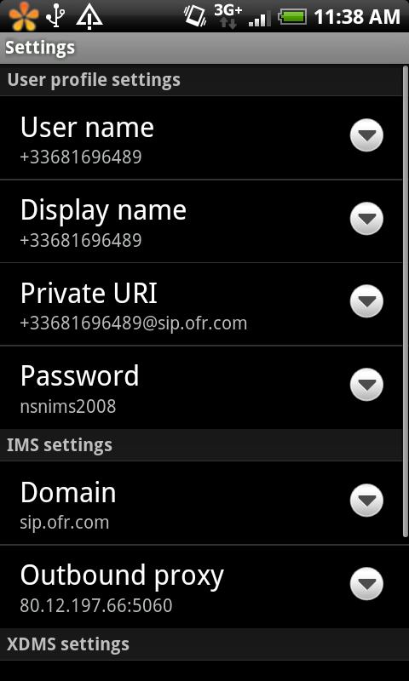

The following IMS parameters should be entered:
- Username: this is the username part of the IMPU.
- Display name: may be any string.
- Private URI: this is the IMPI.
- Password: password used for authentication during registration.
- Domain: home domain.
- Outbound proxy: address and port of the entry point of the IMS platform (SBC or P-CSCF).
- XDM server: address of the XDMS.
- XDM login: login to connect to the XDMS.
- XDM password: password to connect to the XDMS.

The IMPU is then built by using the username and the domain.

Sample:
- Username = “abcd”.
- Display name = “ABCD”.
- Private URI = “abcd_private@domain.com”.
- Password = “xxxx”.
- Domain = “domain.com”.
- Outbound proxy = “127.0.0.1:5060”.
- XDM server = ”127.0.0.1:8080/services”.
- XDM login = “yyyy”.
- XDM password = “xxxx”.

Note: settings are stored into a content data provider.

Note: for any update of the user profile, the RCS service should be restarted.

